**MULTISENSORY FUSION FOR UNDERWATER ROBOT LOCALIZATIONA AND EXPLORATION**

**BY**

**UMAIR ALI**

**18001222019**

**MS Electrical Engineering**

**Department of Electrical Engineering**



**UNIVERSITY OF GUJRAT**

**Session 2018-2020**

**UMAIR ALI M.Sc Electrical Engineering 2018-19**

**MULTISENSORY FUSION FOR UNDERWARTER ROBOT LOCALIZATION AND EXPLORATION**

**A Thesis Submitted in Partial Fulfillment of the Requirements for the Award of Degree of**

**MS**

**In**

**Electrical Engineering**

**BY**

**UMAIR ALI**

**18001222019**

**Department of Electrical Engineering**



**UNIVERSITY OF GUJRAT**

**Session 2018-19**

**ACKNOWLEDGEMENT**

I would like to thank Allah Almighty who blessed me a very motivating and kind supervisor, Dr Muhammad Wasif who has been always available to help me wherever I found any difficulty. He always provided me a challenging environment so I could build up an ability to learn something new. I can not forget his patience, availability and supportive nature so I could complete my thesis on time.

**(Umair Ali)**

**DEDICATION**

Dedicated to my parents who supported me to fulfil my dreams.

**(Umair Ali)**

**DECLARATION**

I Umair Ali S/O Muhammad Sajjad Haider, roll # 18016522-008, MS Electrical Engineering scholar, Department of Electrical Engineering, Faculty of Engineering & Technology, University of Gujrat, Pakistan, hereby solemnly declare that this thesis titled “Multisensory fusion for underwater robot localization and exploration” is based on genuine work, and has not yet been submitted or published elsewhere. I Furthermore, I shall not use this thesis for obtaining any other degree from this university or any other institution.

I also understand that if evidence of plagiarism is provided in my thesis at any stage, even after the award of the degree, the degree may be cancelled and revoked by the University authority.

**(Umair Ali)**

It is certified that Umair Ali S/O Muhammad Sajjad Haider, roll # 18016522-008, M.Sc Electrical Engineering scholar, Department of Electrical Engineering, Faculty of Engineering & Technology, University of Gujrat, Pakistan, worked under my supervision and the above stated declaration is true to the best of my knowledge.

**_____________________**

Dr. Syed Muhammad Wasif

Assistant Professor, Department of Electrical Engineering

University of Gujrat, Punjab, Pakistan.

Email: syed.wasif@uog.edu.pk

Dated:

**THESIS** **COMPLETION CERTIFICATE**

It is certified that this thesis titled “Multisensory Fusion for Underwater Robot Localization and Exploration” submitted by Umair Ali S/O Muhammad Sajjad Haider, roll # 18016522-008, MS Electrical Engineering scholar, Department of Electrical Engineering, Faculty of Engineering & Technology, University of Gujrat, Pakistan, is evaluated and acceptance for the award of the degree”Master of Science (MS)” in Electrical Engineering by following members of the Thesis/ Dissection Viva Voce Examination Committee.

The evaluation report is available in the Directorate of Advance Studies and Research Board of University.

**_________________________**

Name of External:

Designation:

Office Address:

Email:

**_________________________**

Dr.Syed Muhammad Wasif

Assistant Professor, Department of Electrical Engineering

University of Gujrat, Punjab, Pakistan.

Email: syed.wasif@uog.edu.pk

**_________________________**

Dr.Shahid Iqbal

HOD, Department of Electrical Engineering

University of Gujrat, Punjab, Pakistan.

Email: si@uog.edu.pk

|  |  |
| --- | --- |
| **TABLE OF CONTENTS** | |
| **CONTENTS** | **PAGE** |
| LIST OF FIGURES…………………………………………………………….. | **vii** |
| LIST OF TABLES………………………………………………………… | **viii** |
| LIST OF APPENDICES………………………………………………….. | **ix** |
| ABSTRACT……………………………………………………………….. | **01** |
| CHAPTER 01: INTRODUCTION……………………………………….. | **02** |
| 1.1: Problem Statement………………………………..……...……… | **06** |
| 1.2: Objectives and Scope of Study...………………..……..………. | **06** |
| CHAPTER 02: LITERATURE REVIEW………………………………..  2.1: Power Sector Background of Pakistan………………………….  2.2: Overall Structure of Energy Sector……………………………..  2.2.1: National Electric Power Regulatory Authority………...  2.2.2: National Transmission and Dispatch Company…….…..  2.2.3: Water and Power Development Authority……………...  2.2.4: Generation Companies…………………………………...  2.2.5: Distribution Companies…………………………………..  2.2.6: Pakistan Atomic Energy commission……………………  2.2.7: Private Power Infrastructure Board……………………..  2.2.8: Alternative Energy Development Board………………..  2.2.9: Private Power Sector……………………………………..  2.2.9.1: Karachi Electric Supply Company……………..  2.2.9.2: CPP/SPPs………………………………………...  2.2.9.3: Independent Power Producers………………….  2.3: Power Generation from all Source……………………………...  2.4: Power System Losses…………………………………………….  2.4.1: Technical Losses………………………………………….  2.4.1.1: Fixed/Permanent Technical Losses……………  2.4.1.2: Variable Technical Losses……………………..  2.4.2: Non Technical Losses…………………………………….  2.5: Distribution Transformer Losses………………………………..  2.5.1: Copper Losses…………………………………………….  2.5.2: Core Losses………………………………………………..  2.5.2.1: Hysteresis Losses………………………………  2.5.2.2: Eddy Current Losses…………………………...  2.5.3: Magnetostriction………………………………………….  2.5.4: Mechanical Losses………………………………………..  2.5.5: Dielectric Losses………………………………………….  2.5.6: Stray Losses……………………………………………….  2.6: World Scenario of T&D Losses…………………………………  2.7: T&D Losses Scenario in Pakistan………………………………  2.8: Methods for Power Losses Detection and Measurement……...  2.8.1: Distribution Network Segmentation…………………….  2.8.2: SCADA Based Method…………………………………...  2.8.2.1: Collection of Data from SCADA Center……..  2.8.2.2: Collection of Data from Technical Data Base.  2.8.2.3: Collection of Data from Commercial Base…..  2.8.2.4: Calculation Strategy……………………………  2.8.3: Loss Factor Method………………………………………  2.8.3.1: Transmission Line Losses……………………..  2.8.3.2: Power Transformer Losses…………………….  2.8.3.3: Distribution Line Losses……………………….  2.8.3.4: Low Voltage Distribution Transformer Losses  2.8.4: Smart Grid Approach for Loss Detection……………….  2.9: Power Loss Minimization Techniques………………………….  2.9.1: Reactive Compensation through Capacitor Placement...  2.9.2: Reconductoring of Primary and Secondary Sides………  2.9.3: Minimizing Load Unbalance……………………………..  2.9.4: Standardization of Scattered Voltage Lines…………….  2.9.5: Placement of Multiple Distributed Energy Resources…  2.9.6: Volt-VAr Optimization…………………………………..  2.9.7: Prepaid and Advanced Metering Infrastructure………...  2.9.8: Underground Secondary Lines & Secure Service Drops  2.9.9: Distribution Network Reconfiguration………………….  2.9.10: Distribution Transformer Management………………..  2.10: Comparison Statement…………………………………………. | **08**  **08**  **10**  **11**  **11**  **12**  **13**  **13**  **14**  **14**  **14**  **15**  **15**  **16**  **16**  **17**  **18**  **18**  **18**  **19**  **19**  **20**  **21**  **21**  **21**  **22**  **22**  **22**  **22**  **22**  **23**  **24**  **25**  **25**  **27**  **27**  **27**  **28**  **29**  **29**  **29**  **29**  **30**  **30**  **31**  **33**  **33**  **34**  **34**  **34**  **35**  **36**  **37**  **37**  **38**  **38**  **39** |
| CHAPTER 03: RESEARCH METHODOLOGY………………………... | **40** |
| 3.1: Introduction to GEPCO………………………………………….. | **40** |
| 3.2: Electrical Network of GEPCO………………………………….. | **40** |
| 3.3: Case Study of 132KV Grid Station Ratti, Gujrat……………… | **41** |
| 3.4: Study of Electrical Transient Analyzer Program………………  3.4.1: Application of ETAP…………………………………….. | **43**  **44** |
| 3.5: Modeling of Distribution Feeders Using ETAP………………..  3.5.1: Modeling of MMP Feeder………………………………..  3.5.2: Modeling of Gulzar-e-Madina Feeder………………….. | **44**  **45**  **45** |
| 3.6: Calculation of NL Power Loss of Transformers……………….  3.6.1: NL Power Loss of MMP Feeder…………………………  3.6.2: NL Power Loss of SIE Subdivision……………………..  3.6.3: NL Power Loss of GEPCO Network……………………. | **46**  **46**  **47**  **48** |
| 3.7: Annual Line Losses of GEPCO Network……………………….  3.8: Study of Amorphous Core Technology…………………………  3.8.1: Characteristics of Amorphous Metal……………………  3.8.2: Standard NL Losses of Amorphous Transformer………  3.8.3: Reduced NL Losses over Conventional Transformer….  3.8.4: Worldwide Potential Savings…………………………….  3.8.5: Magnetic Properties………………………………………  3.8.6: Environmental Impacts…………………………………...  3.8.7: Efficiency Against Loading……………………………... | **49**  **49**  **50**  **51**  **51**  **51**  **52**  **53**  **53** |
| CHAPTER 04: RESULTS AND DISCUSSIONS………………………. | **55** |
| 4.1: NL Loss Analysis………………………………………………… | **55** |
| 4.1.1: Testing of 200KVA Silicon Steel Transformer………… | **55** |
| 4.1.2: Testing of 200KVA Amorphous Transformer………….. | **56** |
| 4.1.3: Comparison and Calculation of NL Loss………………. | **57** |
| 4.1.4: Summary of NL Loss Analysis………………………….. | **58** |
| 4.2: Economic Analysis……………………………………………….  4.2.1: Electricity Price…………………………………………..  4.2.2: Calculation of Economic Loss and Payback Time……..  4.2.3: Summary of Economic Analysis………………………… | **59**  **59**  **60**  **63** |
| CHAPTER 05: CONCLUSIONS AND RECOMMENDATIONS……… | **65** |
| REFRENCES……………………………………………………………… | **67** |
| APPENDIX-01: Abbreviation Used in the Thesis……………………… | **72** |
| APPENDIX-02: Turnitin Originality Report…………………………… | **73** |
|  |  |

|  |  |  |  |
| --- | --- | --- | --- |
| **LIST OF FIGURES** | | | |
| **CONTENTS** | | **PAGE** | |
| Figure-2.1: Electric Power Development Since 1990s…………………. | | **09** | |
| Figure-2.2: Projected Power Demand and Supply for 2016-2020…….. | | **10** | |
| Figure-2.3: Overview of Energy Sector of Pakistan……………………. | | **10** | |
| Figure-2.4: Role of NTDC among Different Companies………………. | | **12** | |
| Figure-2.5: Private Power Sector………………………………………… | | **15** | |
| Figure-2.6: Total Power Generation in Pakistan……………………….. | | **17** | |
| Figure-2.7: Types of Power Losses and Causes………………………… | | **19** | |
| Figure-2.8: 10KVA Silicon Steel Core Distribution Transformer……. | | **20** | |
| Figure-2.9: Chart of Transformer Losses………………………………  Figure-2.10: T&D Losses with Sales & Auxiliary Consumption………  Figure-2.11: Segments of Distribution System………………………….  Figure-2.12: Flow Chart of Calculating Losses in Power System……..  Figure-2.13: Architecture of Smart Grid…………………………………  Figure-2.14: Detection of Non-Technical Losses in Smart Grid………  Figure-2.15: Non Standard Low Voltage Secondary System…………..  Figure-2.16: Percentage of Feeder Losses in Contrast to DGs…………  Figure-3.1: GEPCO Area of Jurisdiction………………………………...  Figure-3.2: Overall Electrical Network of GEPCO……………………..  Figure-3.3: Single Line Diagram of 132KV Grid Station Ratti, Gujrat.  Figure-3.4: Technical Losses of Ratti Grid Station (2017-2018)……...  Figure-3.5: Main Window of ETAP Software…………………………...  Figure-3.6: Load Flow Modeling of MMP Feeder………………………  Figure-3.7: Load Flow Modeling of Gulzar-e-Madina Feeder…………  Figure-3.8: Contribution of Transformers in NL loss of MMP Feeder..  Figure-3.9: Feeders Contribution in NL Loss of SIE Subdivision…….  Figure-3.10: Atomic Structure of Amorphous & Silicon Steel Metals..  Figure-3.11: Designed Amorphous Core Shape…………………………  Figure-3.12: Reduced Hysteresis Loop of Amorphous Metal………….  Figure-3.13: Efficiency against Loading………………………………... | | **21**  **24**  **25**  **31**  **31**  **32**  **35**  **36**  **40**  **42**  **42**  **43**  **44**  **45**  **45**  **47**  **48**  **50**  **50**  **52**  **54** | |
| Figure-4.1: Experimental Setup for Testing of 200KVA Silicon Steel Core Transformer…………………………………………….  Figure-4.2: Experimental Setup for Testing of 200KVA Amorphous Core Transformer…………………………………………….  Figure-4.3: Comparison of NL Losses of Amorphous & Silicon Core Transformers………………………………………………….  Figure-4.4: Comprehensive Results of NL Loss Analysis……………...  Figure-4.5: Payback Time Period of 10KVA Transformer……………..  Figure-4.6: Payback Time Period of 15KVA Transformer……………..  Figure-4.7: Payback Time Period of 25KVA Transformer……………..  Figure-4.8: Payback Time Period of 50KVA Transformer……………..  Figure-4.9: Payback Time Period of 100KVA Transformer……………  Figure-4.10: Payback Time Period of 200KVA Transformer…………..  Figure-4.11: Payback Time Period of 400KVA Transformer…………..  Figure-4.12: Payback Time Period of 630KVA Transformer…………..  Figure-4.13: Payback Time Period of Overall GEPCO Transformers… | | **55**  **56**  **58**  **58**  **60**  **61**  **61**  **61**  **62**  **62**  **62**  **63**  **63** | |
| Figure-4.14: Results of Economic Analysis…………………………….. | | **64** | |
|  | |  | |
| **LIST OF TABLES** | | |
| **CONTENTS** | **PAGE** | |
| Table-2.1: List of Hydel Units Operated by WAPDA…………………. | **12** | |
| Table-2.2: Name of DISCOs and Electricity Demand…………………. | **13** | |
| Table-2.3: List of IPPs in Pakistan……………………………………… | **16** | |
| Table-2.4: Total Power Sharing from all Sources……………………… | **17** | |
| Table-2.5: T&D Losses by Region (1980-2000)……………………….. | **23** | |
| Table-2.6: Comparison Statement of Power Loss Reduction Techniques……………………………………………………. | **39** | |
| Table-3.1: List of Distribution Transformers in GEPCO……………… | **41** | |
| Table-3.2: Categories of Feeders Emanating from Ratti Grid Station.. | **42** | |
| Table-3.3: Technical Losses of Ratti Grid Station (2017-2018)………  Table-3.4: Standard Losses for Silicon Steel Core Transformer………  Table-3.5: NL Power Loss of MMP Feeder……………………………..  Table-3.6: NL Power Loss of SIE Subdivision………………………….  Table-3.7: NL Power Loss of GEPCO Network………………………...  Table-3.8: Annual Line Loss of GEPCO (2017-2018)………………….  Table-3.9: Standard NL Power Loss of Amorphous Transformer……..  Table-3.10: NL Loss Reduction through Amorphous Transformers…..  Table-3.11: Annual Potential Savings by Amorphous Transformers….  Table-3.12: Reduction of GNG Emission by Amorphous Transformers………………………………………………...  Table-4.1: NL Losses of Silicon Steel & Amorphous Transformers….  Table-4.2: Initial Prices of Transformers………………………………..  Table-4.3: Rates of KWh Units for Domestic Load……………………. | **43**  **46**  **47**  **47**  **48**  **49**  **51**  **51**  **52**  **53**  **57**  **59**  **59** | |
|  |  | |

|  |  |
| --- | --- |
| **LIST OF APPENDICES** | |
| **CONTENTS** | **PAGE** |
| APPENDIX-01: Abbreviation Used in the Thesis…………………….. | **72** |
| APPENDIX-02: Turnitin Originality Report…………………………… | **73** |
|  |  |

**ABSTRACT**

Water covers more than 70 per cent of the earth and most of the underwater area has not yet discovered. For underwater exploration and unusual activity inspection, Unmanned underwater vehicles (UAVs) are used which have lesser cost and no life risks as compared to manned underwater vehicles. The known position is mandatory to make underwater exploration data meaningful but underwater localization is a challenging research topic because of the dynamic and unstructured nature of the seabed environment. Global positioning system (GPS) and other radio positioning systems e.g., cellular networks and Wi-Fi positioning system (WPS) are not suitable for underwater location estimation. Acoustic positioning systems are a better alternative for underwater localization but sound travelling speed is slower than electromagnetic signals. The sensors which can estimate the position in an absolute frame of reference in the underwater environment e.g., visual positioning systems and acoustic positioning systems have slower position update rate. For the sake of reliability dead-reckoning method based sensors like Doppler velocity log (DVL) and inertial measurement unit (IMU) are added. By fusing these sensor modalities the location of the underwater vehicle is located with more accuracy. In the case of fusion of multiple sensors, Kalman filter can not deal with non-Gaussian noise while parametric filter like monte Carlo localization (MCL) has a high computational cost. The particle filter is great for dealing highly non-linear systems but because of expensive computation cost, they are suitable for post-processing. An optimal fusion policy for localization of underwater robot with the low computational cost is an important research question. We proposed PC-BC/DIM neural network which can fuse multiple sensors and optimally approximate position using different sensory information. Simulation results have shown that our proposed filter has only 1.7853 standard deviation error, 3.439 roots mean square error, 0.8 milliseconds of filter processing time with 12.9 seconds of total execution time against 6301 IMU, 6301 DVL and 158 USBL Experimental results have 1.37 root mean square error and 1.05 standard deviation error for the complete trajectory of 693 meters. Proposed PC/BC-DIM neural network can measure the position of an underwater robot more accurately and it can eliminate the highly abrupt noise of USBL sensor.

# CHAPTER- 1

## INTRODUCTION

Pakistan has nearly 1000 kilometre long coast from Sir Creek to Jiwani and according to Law of the sea the coastal countries are allowed up to 200 nautical miles of economic control from its territorial sea baseline. Apart from that Pakistan holds an additional 150 nautical miles of an exclusive economic zone in the deep sea. This vast coastal area comes up with numerous advantages e.g., economic strength from seafood, opportunities to explore underwater resources. Besides these benefits, there are also challenges for the Pakistan navy to monitor suspicious activities of significant sea area. All these challenges encourage researchers to play their role for the sake of economic growth and defence of the country.

Autonomous underwater vehicle (AUV) and remotely operated vehicle (ROV) are most commonly used for underwater operations. ROV is guided vehicle and is applied particularly for sea inspection, maintenance and repairing purposes (Grøtli, Tjønn°as, Azpiazu, Transeth, & Ludvigsen, 2016). AUV is an unguided vessel and practices for general purposes like research, defence and exploration without interference or semi-interference from external guidance (Miller, Miller, & Miller, 2018). Self-localization of AUV is required while performing search operations e.g., in looking for missing ships, sank ships, discovering new species and natural resources. Collection of exploration data is meaningless if an AUV can not determine its exact location (H. Li, He, Cheng, Zhu, & Sun, 2015). Self-localization plays an important role in the control and monitoring of an underwater robot as well as search and rescue operations.

**Figure-1.1: Connectivity of different sensors for underwater localization**

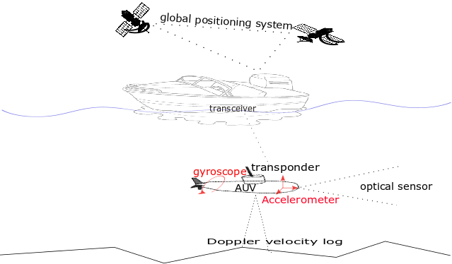

Figure 1.1 is showing the connectivity, between different types of sensors which are used for underwater localization, with the help of dotted lines. The ship is connected to GPS and AUV is connected to the transceiver of a ship through the acoustic transponder. Gyroscope and accelerometer are presented on AUV to find the linear and angular position of an underwater robot, respectively. Optical sensors or sonars are placed on the head of AUV which shows the front view and these can be used to find the position of a vehicle with respect to some fixed landmark. Doppler velocity log sensor produces the velocity of an underwater vehicle which is used to find the position of a vehicle.

Underwater localization of a robot is unalike the localization in the normal territorial environment because of rapid attenuation of noise due to the dynamic and unstructured nature of salty seawater (Paull, Saeedi, Seto, & Li, 2013). Consistent location is estimated with the help of some global and differential position measuring sensors. Global positioning system (GPS) is most commonly used for self-location discovering while some force and orientation measuring sensors are combined for speed estimation and heading correction, respectively. One major limitation for underwater localization is the unavailability of GPS (Leonard & Bahr, 2016) and other electromagnetic signal-based positioning systems e.g., cellular networks and Wi-Fi positioning system etc. Salty conductive nature of the sea is highly impure for penetration of high-frequency radio signals. Similarly, with the increase in the depth pressure on inertial sensor produces abrupt and noisy results.

Sound waves are low frequency or high wavelength signals which can effectively penetrate through the seabed water. Most of the underwater communication is done based on acoustic waves that is why acoustic positioning systems are used for localization in an underwater environment. An acoustic positioning system (e.g., ultrashort baseline, long-baseline, short baseline) results in absolute position measurement in the local environment (Rigby, Pizarro, & Williams, 2006). The connectivity of the acoustic system is shown in figure 1 which is between an AUV transceiver and Ship transponder. Although, sound travelling speed is slower as compared to radio signals but accuracy is not compromised. Delay in the acoustic positioning system can be managed with the support of acoustic velocity sensor which works on the principle of the Doppler effect. Doppler velocity logs (DVL) sensor is an application of the Doppler effect in which the position of an agent is estimated with back-scattering acoustic waves using a dead-reckoning technique where the initial reference of the global position is required for such sensor. There is also a network of acoustic sensors, named as Wireless Sensor Network (WSN), for which multiple algorithms are proposed to localize a robot (Tan, Diamant, Seah, & Waldmeyer, 2011).

In a spatial reference system, egocentric and allocentric techniques are used for underwater robot localization. Using the egocentric approach, the location of an agent is used as a reference for localization of other objects which can be further used for localization of secondary objects using allocentric localization methods (Al-Rawi et al., 2017). Visual positioning system provides an accurate self-location in an absolute frame of reference but with lagging efficiency due to the recognition of objects. Laser-based positioning systems with the aid of some inertial sensor have been used for location estimation in a limited sea area and shallow water.

**Figure-1.2: General idea of multisensory fusion**

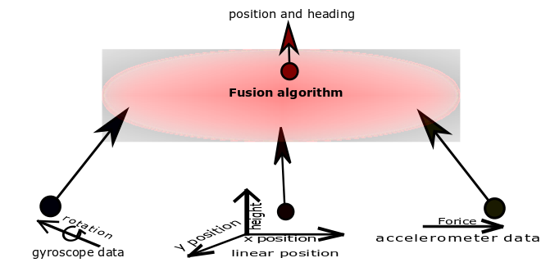

Figure 1.2 is presenting an idea to collect the data from different sensory modalities and to fuse that data of multiple sensors using a fusion algorithm to find the current position and heading of the object.

Each sensor for underwater localization has some limitations e.g., acoustic positioning systems measure the position of an agent with some delay due to the limitation of sound travelling speed and visual positioning systems are dependent on the recognition of predefined objects. Inertial sensors measure change more abruptly with the depth of water and in inverse proportion, the accuracy of velocity measuring acoustic sensors also vary with depth as they need underwater land for back-scattering of sound waves (Medagoda, Williams, Pizarro, & Jakuba, 2011). Due to the limitation of each sensor multisensory data fusion appears as very complex and nontrivial task and it is required to estimate the optimal location of the robot which ensures redundancy resolution and better location estimation as compared to single sensor (Rigby et al., 2006). Figure 1.2 is showing a general idea of multisensory fusion for optimal location in which different inputs are combined together and a fusion algorithm extracts useful features through it. Position, size, identity and distance are some examples of features which can be extracted with the help of a fusion algorithm using raw input data. Specifically, in an unknown underwater environment, where there are no fixed landmarks or predefined maps to recognize the objects and to estimate the self-location of an underwater robot, the acoustic positioning systems are a better alternative than vision-based positioning systems. In conclusion, absolute positioning technologies (e.g., visual or acoustic positioning systems) and dead-reckoning technique based technologies (inertial, velocity measuring sensors) are combined to locate an underwater robot.

### 1.1: Problem Statement

Collection of exploration data in an unknown environment is meaningless when there is no known frame of reference. In the middle of the ocean, there is always ambiguity for location estimation. Radio waves can not travel through salty water of the sea due to its conductive nature and high density. Acoustic positioning systems are the better alternative for underwater position estimation in an absolute frame of reference but results are produced with delayed measurements because of the non-linear behaviour of sound in water. Similarly, vision-based positioning systems need some known objects to refer but noise impurity of water also matters. For underwater self-localization of a robot, every available sensor has limitations. Multisensory fusion is needed for redundancy resolution and optimal location estimation instead of a single sensor for localization in underwater environment. Conventional fusion policies such as Kalman filter can not model highly non-linear noise of the underwater environment. Multimodal hypothesis based techniques such as Monte-Carlo localization have high computational cost even in the presence of reliable sensory data. Optimal fusion policy for an underwater robot localization is required for dynamic and unstructured nature of the seabed environment.

### 1.2: Objectives and Scope of Study

To Main objective of the thesis are

* To investigate available technologies and techniques of underwater localization.
* To examine state estimators and their limitations for underwater multisensory fusion.
* To analyze recent developments for underwater localization
* To develop an efficient and accurate fusion policy for optimal location estimation in dynamic and unstructured underwater environment.

# **CHAPTER– 2**

## **LITERATURE REVIEW**

In this chapter, from a very basic to advance level review is presented. Autonomous Underwater vehicles (AUV) are now converting from prototype to real working robots for scientific exploration and military operations (Mahmoud Zadeh, Powers, & Zadeh, 2019). Available technologies and fusion algorithms with their specifications are discussed below

**2.1: Navigation Systems for Underwater Localization**

Navigation systems are divided into three main categories (inertial, acoustic and geo-positioning systems) for underwater vehicle localization. In literature, these technologies have been used in various projects.

**2.1.1: Inertial or Dead-reckoning**

Most of AUVs are working on dead reckoning principle in which current change is integrated to past states for prediction of position. For underwater localization, the internal or inertial sensory information is used for prediction of location using motion estimation (Ko, Kim, & Noh, 2011). The inertial sensor incorporates error with time and produces inaccurate results. Inertial measurement unit (IMU) is a sensor which is widely used for motion estimation. IMU contains a triaxial accelerometer, triaxial gyroscope and electrical compass for linear, angular and heading, respectively (J. Zhang, Wang, Xie, & Shi, 2014). Motion estimation below the surface of the water is not similar to the territorial environment. Inertial sensors contain unstructured noise of water which can be overcome by the modelling of the sensors (Karras & Kyriakopoulos, 2007). Modelling of underwater sea environment is difficult task that is why estimation of position from motion sensors become a crucial task.

For measuring the velocity of underwater robot, DVL which is sometimes used in parallel with IMU sensor(Lee, Hong, & Seong, 2003). DVL sensor works on the doppler principle and the velocity is estimated. DVL is more accurate in shallow water and with depth (near underwater river ground or ocean floor), its accuracy improves. In DVL sensor acoustic signal is triggered and after backscattering the velocity of the vehicle is estimated (Dukan & Sørensen, 2013) (Hegrenæs, Ramstad, Pedersen, & Velasco, 2016) (Karimi, Bozorg, & Khayatian, 2013). In underwater, DVL is more accurate than accelerometer and its accuracy grows with depth. An accelerometer is comparatively accurate near the surface of the water and DVL is the most time accurate in deep water. DVL is an expensive sensor due to which it is not used for common projects. DVL works on acoustic waves due to which it can face variation in time of arrival. A typical working of DVL sensor is explained in figure 2.1 by (Vasilijevic, Borovic, & Vukic, 2012).

**Figure-2.1: Working principle and geometry of DVL system**

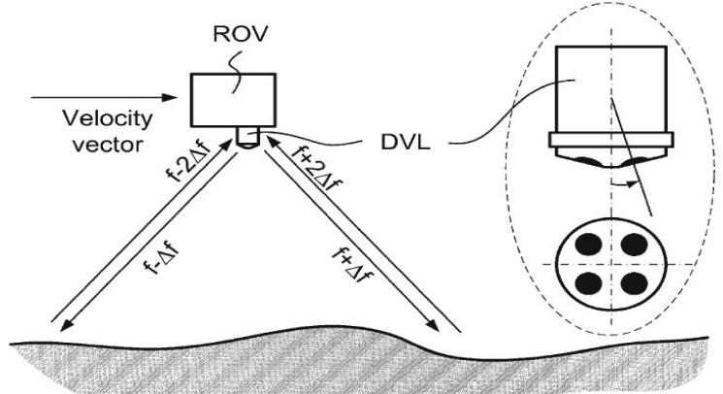

(Vasilijevic et al., 2012)

Figure 2.1 represents the working principle and shape of DVL system which produces a velocity vector. DVL is placed in bottom of an underwater robot. it triggers and receives the back-scattered acoustic signals to estimate the current velocity of an underwater robot. For triggering and receiving of acoustic signals it has 4 windows, each with the angle of 90 degrees from others.

In an underwater environment, inertial sensors are used in both ROV and AUV but the main purpose is always motion estimation and for aid, some other sensors are also integrated with it. In (Aras, Shahrieel, Ab Azis, & Othman, 2012) for building a low-cost ROV, IMU is combined with pressure sensor and compass and this integrated sensor is tested through National Instrument DAQ for 4 degrees of freedom (DOF) in underwater. IMU is comprised of IDG500 (gyro) and ADXL335 (accelerometer) chip for linear and angular movement estimation. As the reliability of IMU varies with the pressure due to which adding a pressure sensor and heading is corrected through the magnetic-resistive compass. Angle of heading is always needed to estimate the angular motion which finally helps to measure the position. In (J. Zhang et al., 2014) IMU is used for 3D location estimation of a robotic fish when the sampling rate is used as 50 Hz. DVL can not be affected by gravity and pressure so acoustic sensors are the better choice for deep underwater odometry or velocity estimation.

In literature, IMU and DVL are integrated by various researchers considering the underwater dynamics of the sea. In (Dukan & Sørensen, 2013) DVL is integrated with other sensors using an integration filter. A DVL has 3 DOF and a 600KHz DVL, with 7Hz ping rate, used by Dukan covers the range of 0.7m to 90m with a standard deviation of 0.3cm/s at 1m/c. Similarly, a new generation DVL is used by (Hegrenæs et al., 2016) which is mounted in the lower part of AUV and has 500 KHz rate with 180m range, 0.2% deviation at 0.1 cm/s.

**2.1.2: Acoustic Positioning Systems**

Over time, dead reckoning based sensors accumulate the residual error and this does not remove until correction or external sensor is added. GPS doesn’t work below the surface of the water and an alternative for GPS is acoustic positioning systems. There are three types of acoustic positioning systems

1. Long baseline (LBL)
2. Short baseline (SBL)
3. Ultra-short baseline (USBL)

**Figure-2.2: Types and geometry of acoustic positioning system**

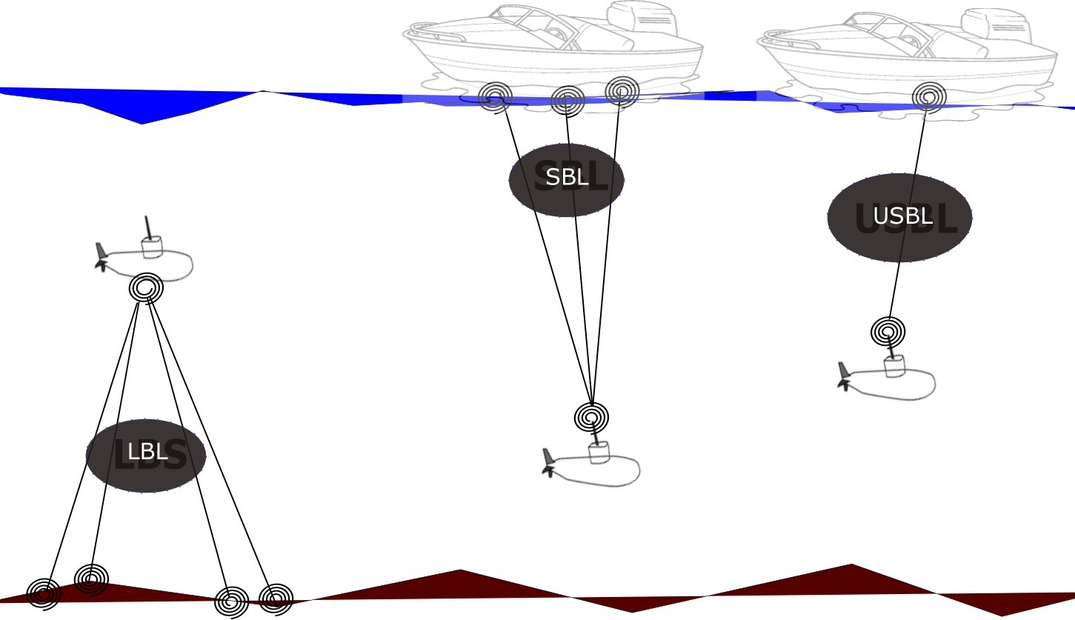

Figure 2.2 is presenting acosutic sensors and their geometry. LBL are fixed nodes and covers large area for an underwater robot localization. SBL uses onboard multiple transducers and one transponder. USBL uses one transducer and one transponder only and has smaller acoustic ranging as compared to SBL and LBL.

In literature, all of these sensors have used for various purposes. Long baseline acoustic positioning systems use 3 or 4 transponders for estimation of underwater position and are very accurate relative to the other two. When there is a system of dead reckoning sensors, such as IMU and DVL, then LBL is used as correction sensor with the help of some fusion algorithms (T. Zhang, Chen, & Li, 2016). LBL is an acoustic sensor and underwater sound travelling is considered as a non-linear system (Lawrence, 1985) which indicate that LBL itself has multiple challenges. SBL is expensive system as compared to USBL and needs more beacons for underwater communication while USBL is used as a stand-alone position estimating system.

LBL is mostly used for underwater sensor networks and USBL has shorter ranges. Due to slower travelling speed, acoustic positioning systems have different time of arrival (TOA). Choosing a USBL in a locally unknown or featureless environment is a better choice. The propagation delay affects the accuracy of the vehicle by addition of non-gaussian noise in USBL as well.

(Caiti et al., 2014) proposed mixed LBL and USBL system for underwater location estimation. In the experiment, LBL is used as fixed nodes with the help of moored modems while a USBL is placed on the Typhoon AUV. IMU has 10Hz rate and it not expensive as DVL that is why IMU is used when Acoustic data is not present. LBL is fixed acoustic nodes which makes underwater sensor network. Multiple Protocols are presented for underwater sensor network and various algorithms are presented for that. The review and challenges are presented in (Heidemann, Stojanovic, & Zorzi, 2012) for an underwater sensor network.

Acoustic systems have a limitation of high delays of arrival, dependency on the environment and low data rates. Sometimes abrupt noise also tempers the useful data so magnetic induction is another technique which is being considered for underwater communication (Akyildiz, Wang, & Sun, 2015). It has comparatively higher data rates but the range is no wider than acoustic position systems in an underwater environment. Magnetic induction technique is not mature enough and is not directly applicable due to directional communication and salty conductive nature of seawater temper conductivity.

**2.1.3: SONAR and vision-based localization systems**

In vision-based localization, the very first task is the recognition of the objects. In some recent advancements regarding underwater localization, the researchers have proposed various useful techniques considering the dynamics of an underwater environment. A visual odometry algorithm is developed for underwater robot localization (Alvarez-Tu ´ n˜on, Rodr ´ ´ıguez, Jardon, ´ & Balaguer, 2018) in which from the pictures features are extracted and matched for location determining. such image-based location estimation is quite accurate although the problem we can face is delaying in recognition. Different colors and intensities differentiate images and region of interest is selected by segmentation which are further used for odometry data measurement (Chen, Zhang, Dai, Bu, & Wang, 2017). Acoustic systems are considered as expensive sensors and contain non-linear noise. Monocular vision system containing a single camera is a better alternative than other positioning systems in a known environment for underwater localization. Camera estimates location with the delay of recognition and it is also dependent on known objects for reference. Low cast pressure sensor and IMU are integrated with a camera to make a Monocular Odometry for underwater vehicles (Creuze, 2017) for pose estimation. Similarly, (Ferrera, Moras, Trouve-Peloux, & Creuze, 2019) proposed visual odometry algorithm which is tested on different noisy images.

**Figure-2.3: Visual localization approaches**

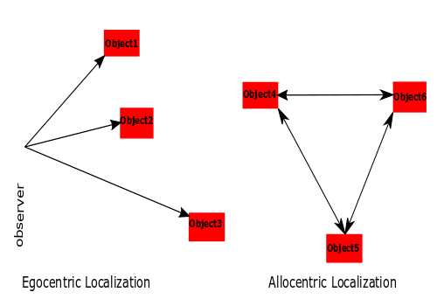

Figure 2.3 is representing the egocentric and allocentric localization concept.

Robot location can be estimated online using imaging sonar which gives better position measurements than dead reckoning using DVL and gyroscope (Johannsson, Kaess, Englot, Hover, & Leonard, 2010). For a partially structured underwater environment (e.g., dams, port) EKF is used to extract the line features and AUV is localized with the help of 360-degree sonar (Ribas, Ridao, Neira, & Tardos, 2006). Like a camera, there are limitations for sonar-based localization systems. Sonar-based algorithm of self-localization of AUV is presented in (Petrich, Brown, Pentzer, & Sustersic, 2018) which is a robust technique for localization.

The magnetic compass is another geo-referred device and in underwater localization, it is also a part of IMU and the main purpose of a compass is correcting the heading using the Geomagnetic field. For angular motion estimation using an odometry data, absolute heading angle is needed which is obtained from compass.

**2.2: Fusion Algorithms for Underwater Localization**

For underwater localization using multi-sensor fusion (MSF) various methods are discussed in (Pan & Wu, 2016) (Tan et al., 2011) (Leonard & Bahr, 2016) (Paull et al., 2013).

**2.2.1: Kalman Filter**

Kalman Filter is a stochastic filtering based state estimating algorithm that comprises prediction and estimation stages. Figure 2.4 is showing the general working of the Kalman filter in which the filter gives the hypothesis of location by combining prediction hypothesis of filter and measurements of sensory data. In (Karras & Kyriakopoulos, 2007) Kalman Filter is used to fusing inertial and visual positioning sensory information for an approximation of location from a fixed earth reference but results can not satisfactory for deep water because of addition of non gaussian noise. A chronological linear state estimator performs poorly in presence of non-linear motion equations of the underwater environment. The underwater environment can not be modeled using linear concepts due to which prediction hypothesis can not be accurate and there will be no overlapping of the output of Kalman filter.

**Figure-2.4: Working principle of Kalman Filter**

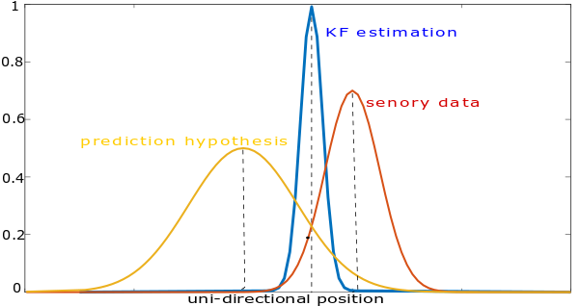

**2.2.2: Extended Kalman filter**

Extended Kalman filter (EKF) is used for converting the non-linear system to locally linear by involving Taylor series expansion and it is based on ”minimum mean square error” estimation principle. A general configuration of the EKF is presented in 2.5 figure. To produce a single state vector of underwater location from various sensory information, Extended Kalman filtering methods are investigated in (Ranjan, Nherakkol, & Navelkar, 2010). To somehow EKF can model some non-linear models but it increases computational cost. As seawater is highly dynamic so EKF also has limitations in underwater location estimation e.g., for underwater environment noise covariance matrix is difficult to obtain and a constant covariance matrix can not be used for dynamic scenarios. An adaptive EKF is proposed for dynamic covariance matrices in (Shao, He, Guo, & Yan, 2016) considering prior limitations. Similarly, using online maximization estimation approach, a new adaptive EKF is presented to update noise and prediction covariance matrices for underwater vehicle localization (Huang, Zhang, Xu, Wu, & Chambers, 2017). EKF is a locally-linear model and follows Gaussian distributions.

Ground speed, heading, altitude and depth is integrated using EKF by (Ribas, Ridao, Cuf´ı, & El-fakdi, 2003). In (Karimi et al., 2013) ROV is simulated for underwater localization in Matlab in which main sensor IMU and auxiliary sensor DVL are used for motion estimation.

**Figure-2.5: Typical Extended Kalman Filter scheme**

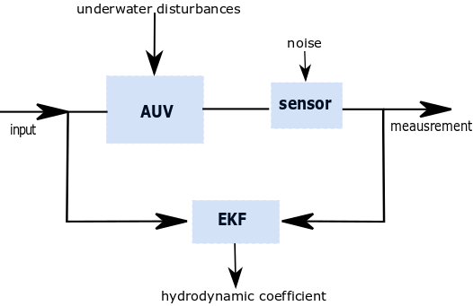

In (Tal, Klein, & Katz, 2017), Tal has integrated the accelerometer and gyroscope data into an inertial system which is further corrected by auxiliary sensors to feed to an EKF. EKF accurately able to find the next state and simulated environment showed that Technion Autonomous underwater vehicle (TAUV) performed better with EKF state estimator.

**2.2.3: Unscented Kalman Filter**

Unscented Kalman filter (UKF) does better approximation than EKF because it considers true deviation points and does transformation through weighted sample mean and covariance (Wan & Van Der Merwe, 2000) (Sabet, Sarhadi, & Zarini, 2014) (Allotta et al., 2016). UKF has been used for vision-based systems as well as for other sensory information fusion for underwater localization. A UKF in (Lebastard et al., 2010) is used to recognize the sphere with which reference the location of a vehicle is estimated. With the depth of the sea, the performance of each sensor varies so (Ko, Noh, & Choi, 2014) proposed simultaneous estimation of the pose of vehicle and depth of sea using UKF but terrain should be known. Although commonly UKF converges accurately, in case of high variance EKF is a better choice than UKF (Rhudy, Gu, & Napolitano, 2013) and accuracy of UKF improves by increasing sigma points. UKF is a non-linear model and follows gaussian distributions so it has relatively higher computational cost than EKF. Figure 2.6 is showing the convergence of UKF and EKF which briefly describe the convergence attitude of EKF and UKF. Accuracy of UKF is better than EKF but with more sigma points the computational cost of UKF increases.

To achieve the best possible accuracy research proposed various schemes. In (W. Li, Wang, Lu, & Wu, 2013) a novel scheme is proposed in which DVL and strap-down inertial navigation system (SINS) are deployed and for alignment adaptive UKF is used. UKF working is similar to a KF as both filters predict the mean and covariance before updating measurements. By using adaptive UKF measurement noise covariance is estimated hence to improve the performance of UKF which finally produces more accurate results. A navigation filter based on UKF is presented by (Allotta et al., 2015) for two Typhoon (TifOne and TifTu) AUVs. AUV offers robust behaviour against different sensor configuration. It is concluded that UKF is more accurate for underwater localization and accuracy improves in the presence of USBL.

**2.2.4: Particle Filter**

In literature for underwater localization, researchers have also work on non-Gaussian distribution. In specific particle filter (PF) is the non-linear model which approximates noisy measurements to produce less noisy results. PF has more expensive computational cost than UKF and EKF. The motion of AUV and underwater location estimation of the acoustic positioning system are highly non-linear processes and contain non-gaussian noise so (Rigby et al., 2006) used PF for the fusion of USBL and DVL sensors. Due to multiple hypothesis particle filters gives delayed results even when there is reliable sensory data but accuracy is not compromised. (Petillot et al., 2010) Presented a method of underwater localization for AUV in the structured environment. Particle filters rely on Monte Carlo approximations in which a large number of particles are distributed for achieving massive accuracy.

In (Mandic, Renduli c, Mi skovi c, & Na, 2016), OWTT-iUSBL system uses a known waveform which is triggered by beacon that is present at the known place. AUV captures the signal with the help of Tetrahedral Hydrophone array. The Particle filter is used which obtain the information from sensor data and fuse it with the motion model. It is proposed that particle filter produces more accurate trajectories for AUV. Most of the underwater simultaneous localisation and mapping (SLAM) work is done using a particle filter. Guillem (Vallicrosa & Ridao, 2018) has used particle filter for state estimation of AUV Virtual and real environment. The proposed technique is capable of running online and represent the environment more accurately. Table is giving specifications of conventional filters for underwater localization.

**Figure-2.6: Comparison of Unscented Transform (UT) and EKF**

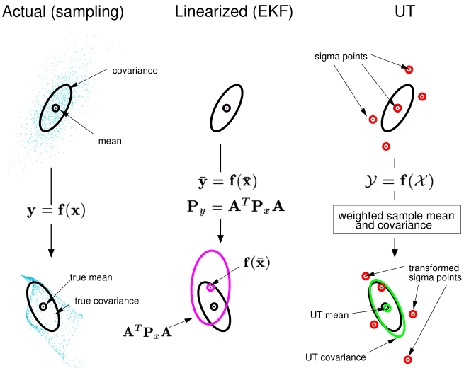

(Wan & VanDer Merwe, 2000)

|  |  |  |  |  |
| --- | --- | --- | --- | --- |
| Table-2.1: Comparison of conventional state estimators for UWL | | | | |
| **Filter** | **Working principle** | **Model** | **Computational cost** | **Distribution** |
| KF | Unimodel hypothesis | Linear | Low | Gaussian |
| EKF | Taylor series expansion | Locally linear | Low - medium | Gaussian |
| UKF | Sigma point distribution | Non-linear | Medium | Gaussian |
| PF | Multi-model hypothesis | Non-linear | High | Non-Gaussian |
|  | | | | |

**2.2.5: Machine Learning Methods**

Machine learning methods are preferred to deal with highly non-linear systems, nowadays. The main focus of the researchers for underwater localization is to use neural networks. Least squares regression formulation presented in (Dellaert & Kaess, 2006) saves the past states for posterior state estimation and is a better scheme than the Extended Kalman filter for underwater localization. Chame (Chame, Dos Santos, & da Costa Botelho, 2018) proposed principle of contextual anticipation in which, with every coming reliable measurement of global sensor, the anticipation span resets to overcome abrupt noise. This anticipation span can neglect the unexpected noise of global positioning sensor but there is still massive noise of inertial sensors. Sabra (Sabra & Fung, 2017) proposed a novel underwater localization scheme called Best Suitable Localization Algorithm (BSLA). BSLA dynamically fuse multiple position estimates of sensor nodes using fuzzy decision support system of selecting a suitable algorithm.

For a single onboard vehicle one approach to overcome noise is modelling of non-linearities by supervised learning (Fang, Wang, & Fan, 2019) but this is suitable where system repeat patterns and task conditions remain almost similar between training and execution time. To identify the reliability of acoustic positioning sensor is the main challenge for the autonomous underwater vehicle because of long delaying in its measurements (Gopalakrishnan, Kaisare, & Narasimhan, 2011). Sonar or other vision-based sensors sometimes give delayed measurements due to various signal processing reasons. Time delaying estimation is made in (Houegnigan et al., 2017) where a neural network is used to estimate the possible delay of acoustic positioning sensor for more consistent results.

**2.2.6: Bio-inspired Approaches**

Some bio-inspired work is presented demonstrating the location estimation just like a fish senses the flow rate under the water and using the predefined map the location can be estimated (Muhammad, Toming, Tuhtan, Musall, & Kruusmaa, 2017). Similarly based on mammals navigation Dolphin SLAM (Silveira et al., 2015) approach is presented which is appearance-based localization method and in contrast to probabilistic methods low-resolution sonars and images can be used for underwater localization.

# CHAPTER- 3

## RESEARCH METHODOLOGY

Location of exploration data is meaningless without a reference of known location and the underwater environment is highly nonlinear. Various methods are employed for the purpose to locate an underwater vehicle for the structured and unstructured environment but available techniques are either not able to predict underwater location accurately or have high computational cost. The main challenge for underwater localization is to predict underwater location accurately in an optimal way. A novel neural network-based technique is proposed in which weights are set intuitively. Each sensory information is encoded into a gaussian format and it is processed through the filter of equidistant weights. The proposed method not only predict individual sensory information with accuracy but it also fuses the sensory information of global and inertial sensor. The general idea of the proposed neural network is presented in 3.1 figure. The proposed PC/BC-DIM neural network and simulations are described in below sections.

### 3.1: PC/BC-DIM Neural Network

PC/BC-DIM is a hierarchical neural network in which predictive coding (PC) (Huang & Rao, 2011) is made compatible with Biased Competition (BC) (Spratling, 2008) and that is implemented using Divisive Input Modulation (DIM) (Spratling, De Meyer, & Kompass, 2009). A processing stage of the network is made up of three different neuron populations. The functioning of each neuron population is expressed in 3.1, 3.2 and 3.3 equation.

|  |  |  |
| --- | --- | --- |
|  |  | (1) |
|  |  | (2) |
|  |  | (3) |

where x, e and r are input vector, error and reconstruction neuron activation functions respectively having the size of m by 1 for each. y is a vector of prediction neuron activations having the size of n by 1. W is a matrix of feed-forward synaptic weight values with the size of n by m and V is the normalized transpose of W. The mathematical operators and are used for point to point multiplication and division respectively. Value ofis to prevent prediction neurons from becoming non-responsive and it also sets the baseline activity rate of prediction neurons. Value of is to prevent division by zero and determines the required minimum strength of input to effect the response of prediction neurons. Prediction neurons activation (y) are initialized with small random values or with zero values. The PC/BC-DIM network iterates for a number of iterations to determine stable response of the each neuron population activation.

**Figure-3.1: PC/BC-DIM processing stages**

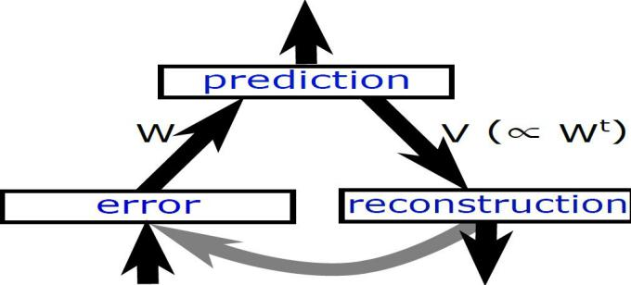

The input of PC/BC-DIM network is termed as causes which is encoded into useful information. Every new input play its role in training of weights. Adding up same sensor input not only increases the size of weights but it also consuming more computation and makes the network process slow. To overcome this situation the proposed network can be trained on the explaining away pattern of reasoning in which the same sensor input is not required and only different information from weights is considered to update the weights. The values of y are prediction points for distinct causes and expected input is obtained under these prediction points. The difference of reconstructed input r and actual input x is represented with e. Weights W is the most important part of the network because it sets the possible range of causes. Each row of W is like a basis vector or elementary component of the whole system. The divisional approach is considered to minimize the error in PC/BC-DIM network instead of a subtractive method as the subtractive mathod converges to solution more slowly and solution is less sparse furthermore subtractive method is less biological plausible.

**Algorithm-3.1: ActivationPCBC(x,W)**

1: for i = 1:iterations

2: r = V*y

3: e = x ./ (e2 + r)

4: y=(e1+y).*(W*e)

5: end

PC/BC-DIM can perform computations with probability distributions when input is a probability function. Weights are the elementary components so every specific input can be reconstructed from these weights. PC/BC-DIM has the ability to reconstruct noiseless signals. The figure 3.2 is showing that how a noisy cause reconstruction through PC/BC-DIM neural network.

**Figure-3.2: PC/BC-DIM processing stages**

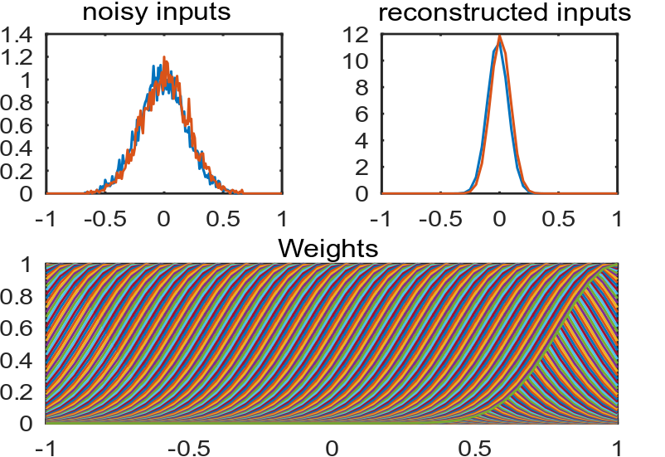

Sensory measurements of underwater robot are just discrete values of position and they are mixed with a abrupt and non-gaussian type of noises. Weights are considered as a modelled system that is why input stimulus decides the nature of weights of network. PC/BC-DIM network weights are set intuitively and less noisy reconstructed results are obtained using noisy sensory data. Input of sensors can be encoded in various formats and to encode them into probability density function one-dimensional Gaussian equation is used and presented in equation 3.4.

|  |  |
| --- | --- |
|  | (3.4) |

A single dimensional gaussian encoded input is used to set a weight vector in W weight matrix until the training of weights completes. For a trained network encoded input is processed from the network for some number of iterations. For a medium size network 25 numbers of iterations are enough to produce a stable reconstructed input. Reconstructed input can be decoded back with the help of the equation.

|  |  |
| --- | --- |
|  | (3.5) |

where μ is the mean value of probability density function (PDF) where zi is the activation of neuron i and si is a receptive field (RF) of neuron i. Similarly, the variance can be calculated using the equation below

|  |  |
| --- | --- |
|  | (3.6) |

The filter has the ability to combine likelihood of the prior to calculate the posterior probability. Fusion or integration of multiple causes is another ability of the filter.

**Figure-3.3: PC/BC-DIM working principle**

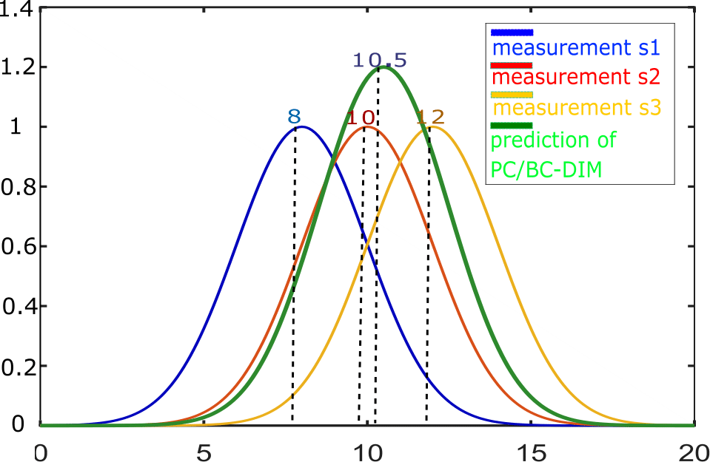

**3.1.1: Training of Weights**

In a neural network, the main part is always training of weights. In PC/BC-DIM input makes the weights so weights are dictionary for all possible inputs. One way to train the weights is to store non-noisy different type of inputs in a matrix form but in simulations, weights are intuitively set for convenience to observe the performance of the network. The weights for all sensors is shown in the figure 3.4. In simulations, all weights are concatenated like all sensors and reconstructed input r is obtained

**3.1.2: Multisensory Data Fusion**

In real-time experiments, there are always multiple sources of information about the same sensory stimulus. This sensory information can be obtained from the same sensory modality or different sensory modalities for the same task. Purpose of multisensory fusion is to determine a single estimate for a different type of information which obtained from different sensor modalities. For example, human performance in cue integration is optimal as it can use different sensory information for the same task by considering the reliability of every cue. PC/BC-DIM has the ability to optimally integrate these sensory modalities. The figure 12 is demonstrating the integration of two sensory cues which are present at a different location. Their weights, actual input, prediction neuron and reconstructed input is mentioned

**Figure-3.4: Trained weights of multiple sensors**

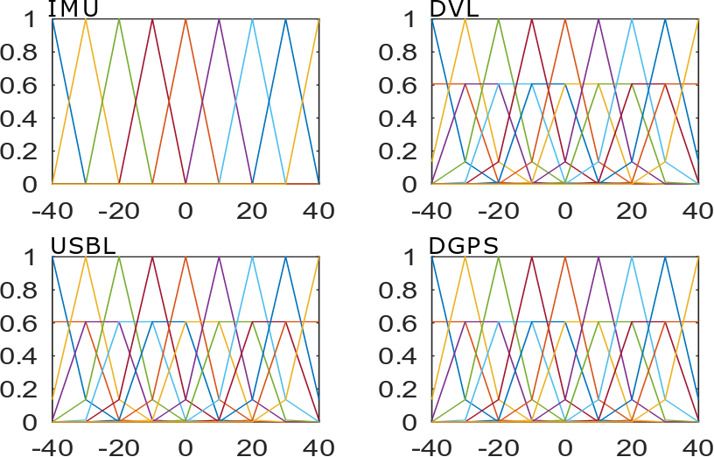

**Figure-3.5: Fusion of two types of sensory inputs**

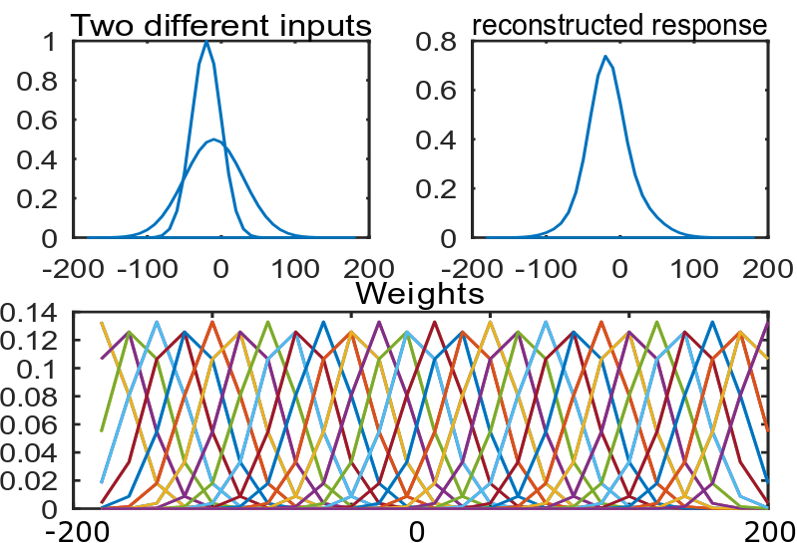

### 3.2: PC/BC-DIM Neural Network

To localize an underwater robot dead-reckoning method based and absolute positioning sensors are used. Each sensory data is first encoded into the individual probability density function (PDF) and these concatenated encoded inputs are processed from PC/BC-DIM neural network to achieve a best possible single probability density function as reconstructed input r. This reconstructed input r is decoded using equation to find a single mean value which indicate the optimal position. For that purpose mean and variance of each sensor is required to find. The mean value is selected as the actual measurement of the sensor and variance is a possible range of that sensory value. Each encoded sensory data has the size of (m by 1) while after combing all sensors the data will be a vector of size (N times m by 1), where N indicates the number of all sensors. Amplitude and deviation of each encoded input are the same as weights of respective input.

**3.2.1: Sensors for Simulations:**

One dimensional and same nature of information (e.g., position, heading etc) is processed from the filter at a time. In the implementation section IMU, DVL, USBL, and DGPS systems are used to estimate the location of AUV. IMU and DVL are dead-reckoning sensors that is why they have to integrate previous states to estimate the current state. USBL and DGPS result in an absolute location of an autonomous underwater vehicle.

GPS doesn’t work below the surface of the water but has a fine accuracy above the surface of the water. USBL is an alternative of GPS which can work below the surface of water. Absolute location points of UAV can be located with the help of USBL but there is always delay in the time of arrival acoustic signal. Other than having low data rate the USBL also contains noise due to disturbances caused by the underwater environment. As support, some dead reckoning sensors are added in which IMU is a very well known sensor. So collectively the unavailability of a low rate positioning sensor in an underwater environment is aided with the help of IMU and DVL.

Dead-reckoning sensors specially IMU contains nonGaussian noise in underwater environment. From IMU the position of an underwater vehicle is derived by double integration of accelerometer data. IMU can not completely estimate the position of an underwater vehicle due to the presence of underwater noise. For redundancy resolution and improving accuracy, DVL sensor is added in parallel to IMU. DVL is more accurate in shallow water, but in deep water it has concerns as well because the velocity of underwater robot is estimated with the help of backscattering acoustic signals. These acoustic signals trigger from the underwater robot and after backscattering from the earth below the surface of water these signals help to estimate the velocity of AUV. To estimate position adding up previous states to current state produces a residual error which can be corrected by positioning sensor.

**3.2.2: Encoding of Sensors**

Every sensor has either limitation of reliability or accuracy so that each sensor is encoded with different variance and the maximum peak value of every encoded sensor is one. The figure 3.6 is showing the 5th value of all sensors. Equation 3.4 is used for encoding each sensory input. One point to note is that exact real measurements of sensors are not directly used. The encoded input is processed from PC/BC-DIM neural network and reconstructed output will return the exact location. Each sensor is concatenated to a single vector before processing from the network. The equation of sensor encoding has three main parameters of inputs, centers and standard deviation.

|  |  |
| --- | --- |
|  | (3.7) |

Range is the distribution of inputs and c is center or mean of respective input. s is the deviation of input and A is amplitude which is set equal to 1.

**Figure-3.6: Encoding of Sensory Data**

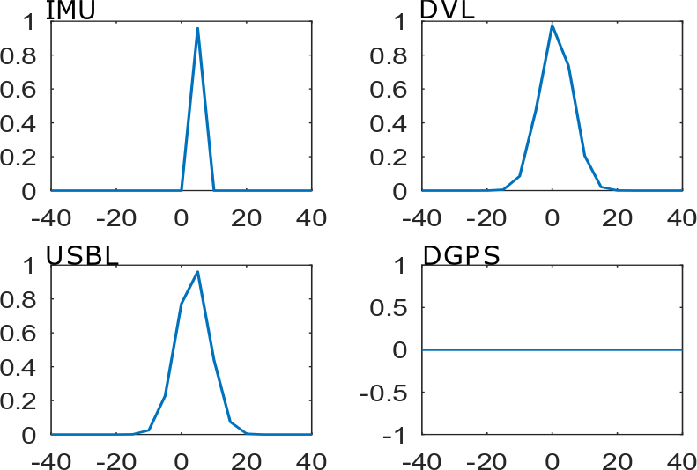

**3.2.3: Decoding of reconstructed input**

With the help of decoding equation the mean values of reconstructed input is selected. PC/BCDIM is not only reconstructed each input but it alse fuses multiple sensory data. Reconstructed input can return diversity in results based on experience because of the deviation of each sensor and weights. If the range is selected from 0 to 40 with the difference of 10 and sigma is selected as 1 then the output will saturate on the multiple of 10s (e.g.,0,10,20,30 and 40). With the increase in variance of sensor and weights, the distribution of output will scatter. Value of reconstructed input also depends on the shape of weights. If prior information of specific type is available then reconstruction of input will be according to that likelihood.

**3.3: Algorithm of PC/BC-DIM for Underwater Localization**

As generally there are two types of sensory information is available. One is an inertial or dead reckoning and second is global fixes information. For global or absolute position estimation the difference of last position (during the presence of global position) from the current position is feed to the PC/BC-DIM network. Inertial sensors are integrated until global fixes correct the residual error of the dead-reckoning sensor and then these are reinitialized to zero. The algorithm is presented below for an underwater robot localization using PC/BC-DIM neural network. WI are weights of inertial sensor and WG are weights of global sensor which are concatenated and stored in W synaptic connection weights. MvalG is input of global sensor and MvalI is inertial input. Until the last value, the filter consistently update multiple sensory inputs with a single reconstructed response r. Inertial values are integrated with previous and global value takes the difference of last value as sensory input. If there is no value present for any sensor then encoded input is assigned with zeros. x is concatenated input and r is reconstruction response. Location is determined by the decoding r response.

In algorithm 3.2 first weights are trained then inertial sensory data is accumulated until the positioning data comes. When any positioning sensor measure location then the current position of the sensor is subtracted from the decoded position. This decoded position is the value of decoded PC/BC-DIM filter on arrival of last positioning data. Accumulated inertial measurement resets to zero when change of position is processed with it from PC/BC-DIM filter. When positional data is not available it is encoded with zeros of same size.

**Algorithm-3.2: Underwater robot Localization using PC/BC-DIM Algorithm**

1: W= [WI WG]

2: [n,m] =size(W)

3: y =zeros(1,n)

4: Mval_G =reference

5: Mval_I =0

6: **while** val= FinalValueSensor **do**

7: **if** valI is present then

8: MvalI+=valI

9: xInertial= Gaussian(MvalI)

10: **else**

11: xInetial= zeros(:,m/size(sensors))

12: **end if**

13: **if** valG is present

14: xGlobal= Gaussian(valG-MvalG)

15: **else**

16: valG (zeros(:,m/size(sensor))

17:  **end if**

18: x = [xInertial xGlobal]

19: r = ActivationPCBC(x;W)

20: location = decode(r(1:length(xGlobal)))

21: **if** sum(xGlobal)!= 0 then

22: MvalG = location

23: MvalI = 0;

24:  **end if**

25: **end while**

# CHAPTER- 4

## RESULTS AND DISCUSSION

In this chapter simulations and experimental results are discussed. As a support of proposed method some basic trajectories are presented with noisy positions. Using PC/BC-DIM the noise is reduced and a very closer trajectory to the actual noise free or ground truth trajectory is obtained.

**4.1: Demonstration of PC/BC-DIM results:**

For x axis cosine function and for y axis sine function is selected with the parameter t from 0 to 2π. By setting x=cos( t ) and y=sin( n * t ) multiple shape trajectories are obtained with n integer values. For circle equation n=1 and in following cases different type of noise reduction using PC/BC-DIM will be discussed.

**4.1.1: random noise addition:**

First, a circle is made by equation x=cos( t ) and y=sin( t ) where t has 500 values from 0 to 2π. Here, x and y represent the ground trajectory without any noise. Random noise is added to this trajectory to make noisy gps values according to 4.1 and 4.2 equations. Green points in figure 4.1 represent the noisy GPS points and noise_const is 0.1 for gps positioning points. First and last element of x and y is the starting and ending point it trajectory, respectively. Red line is showing the outcome of decoded values of PC/BC-DIM neural network.

|  |  |  |
| --- | --- | --- |
|  | x_gps = x + noise_const (randn(length(x),1)) | (4.1) |
|  | y_gps = x + noise_const (randn(length(y),1)) | (4.2) |

Sigma of PC/BC-DIM inertial inputs and weights is 10 and for global inputs and weights sigma is 5. The range and centers are set -5 to 5 with the difference of 2. As in this case there is only noisy position and no inertial sensory data is made so only previous decoded position is fed to network. Figure 4.2 shows the output against noise_const 0.2 for gps points. This shows that with a very high noise still the PC/BC-DIM is producing closer results to ground noise-free trajectory.

**Figure-4.1: PC/BC-DIM outcome for noisy positioning points**

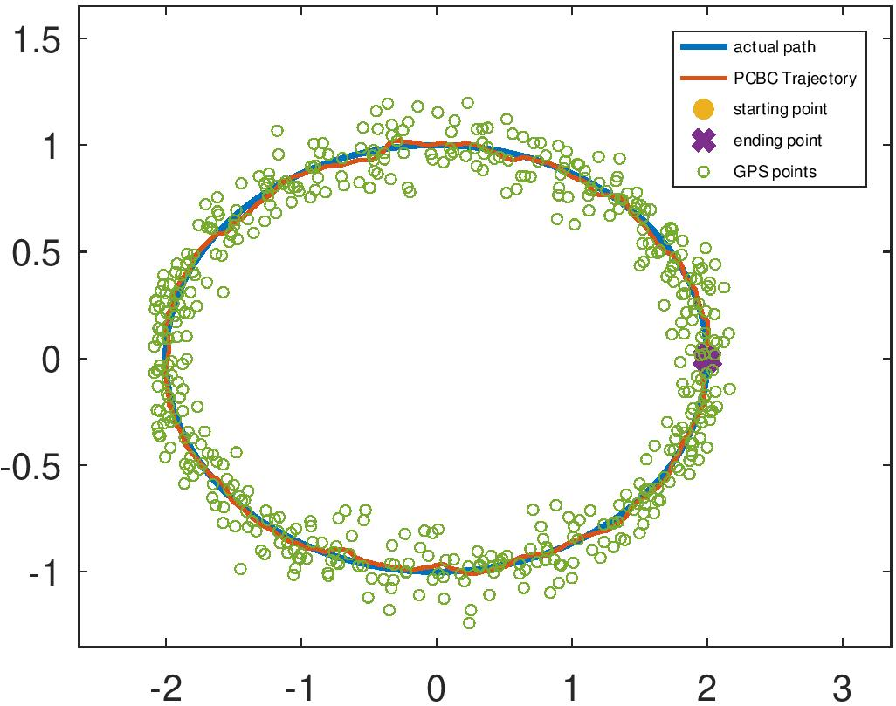

With experiment it is observed that by increasing the number of positioning points the trajectory of PC/BC-DIM neural network improves.

**Figure-4.2: PC/BC-DIM outcome for 2 times noisy positioning points**

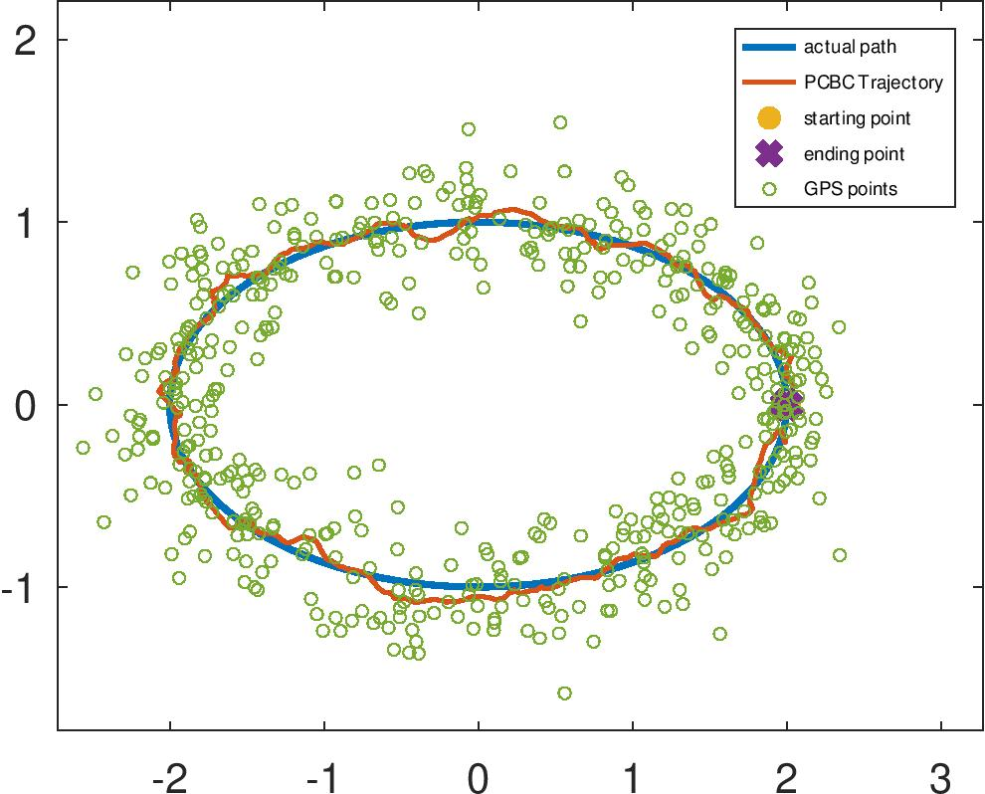

**4.1.2: Non-Gaussian or abrupt noise addition:**

Abrupt noise is the common problem of ultrashort baseline sensor and it is observed that this noise is overcome by PC/BC-DIM using a defined approach. To demonstrate this problem random high noise is added at different indexes of noisy gps signals. Range and centers are set -2 to 2 with the step size of 0.1 while sigma of inertial and global input is set as 1. It is already mentioned that when there is no inertial sensory data available then last decoded position of global sensor is used instead of it. Figure 4.3 is showing the abrupt noise at different indexes of y_gps axis. In described approach if change goes beyond the range then it is ignored by the neural network and previous decoded input is used instead of noisy values as GPS is showing in its trajectory.

**Figure-4.3: PC/BC-DIM outcome for non-Gaussian or abrupt noise**

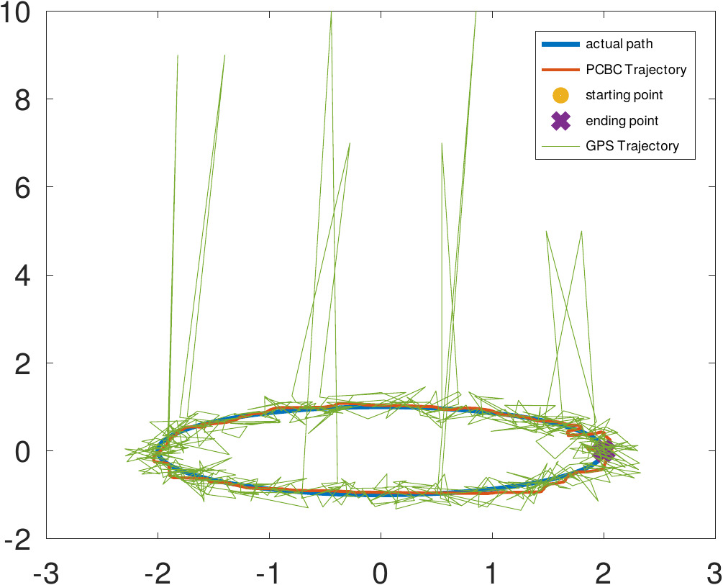

**4.2: Comparison with a recent technique:**

Ranges for inputs is set from -40 to 40 with the difference of 5 and distribution of centres is same but with the difference of 10. IMU is a very noisy sensor it is not wise to involve every value of it that is why its deviation is 1 so it always approaches to some standardized values instead of abrupt sensory values. DVL is more accurate than IMU so its deviation or variance is set as 5 like USBL and DGPS to involved almost every value of each sensor. If at any instant when there is no data available then encoded input is assigned with zeros. DGPS is not presented in an underwater environment figure 13 is showing zeros values.

For experiment collectively IMU, DVL, USBL and DGPS are used. Simulation data is taken from (Chame et al., 2018) in which a ground truth (GT) is the actual noise-free trajectory. For IMU data double derivative of GT trajectory is taken and noise is added to it so that it diverges from reference GT trajectory by adding previous values of IMU. DVL data is a single derivative of GT with some noise so it is less noisy than IMU data. From reference GT trajectory with the equal time difference, various points are selected and in those selected point abrupt values are added. DGPS works fine above the surface of the water so similar GT values are selected for DGPS sensor.

The simulations are conducted in an open-source software named as GNU Octave. To compare results, sensory data is the same which was used by (Chame et al., 2018). Sensory data of simulations include IMU, DVL, USBL, DGPS and Altimeter. Altimeter sensor is not used as a proposed filter gives optimal location without any manual switching. Ground truth data is actual trajectory while all other sensory data is derived from it. IMU data is simulated by twice the differentiating and adding noise to it so integrating the measurements diverge from the original trajectory. Similarly, DVL is one time differentiated and noise is added that is why it is relatively accurate than IMU. USBL data is obtained by selecting instances from ground truth and abrupt noise is added to some of the instances. DGPS is same as ground truth but a few values are taken. USBL has slow data rates as compared to other sensory data.

Above figure is demonstrating the visual difference between two filters using same sensory data. It is clear that PC/BC-DIM is returning more converging results. B-PR-F has two behaviour of deep and near surface while PC/BC-DIM has optimal attitude without any manual switching of any sensor. Green trajectory is showing ground truth data.

Statistical comparison gives more clear differences. Table one shows the differences

|  |  |  |  |  |  |
| --- | --- | --- | --- | --- | --- |
| Filter | Mean Sq Error | std Error | RMS error | Time of execution(s) | Filter time |
| P-PR-F | 51.078 | 2.0788 | 6.8385 | 15.612 | 0.00237 |
| PC/BC-DIM | 15.013 | 1.7864 | 3.439 | 12.900 | 0.00080 |

**Figure-4.1:**

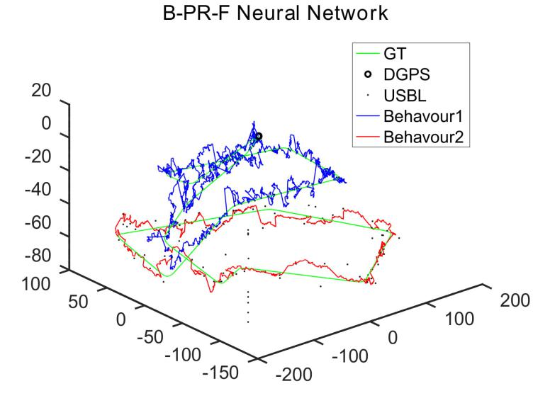

**Figure-4.2: Encoding of Sensory Data**

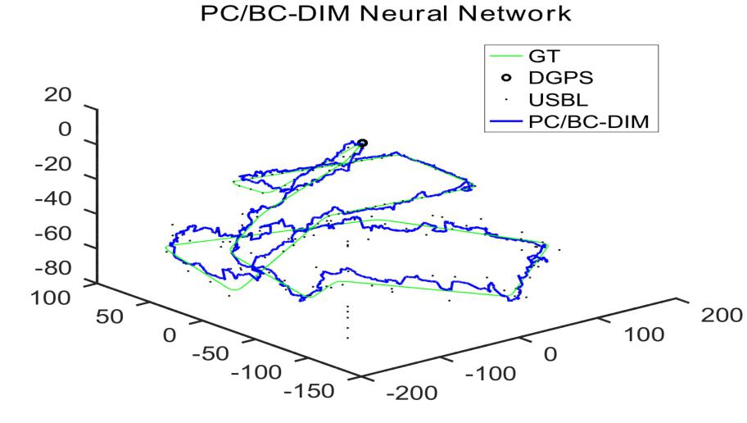

**Figure-4.3: Encoding of Sensory Data**

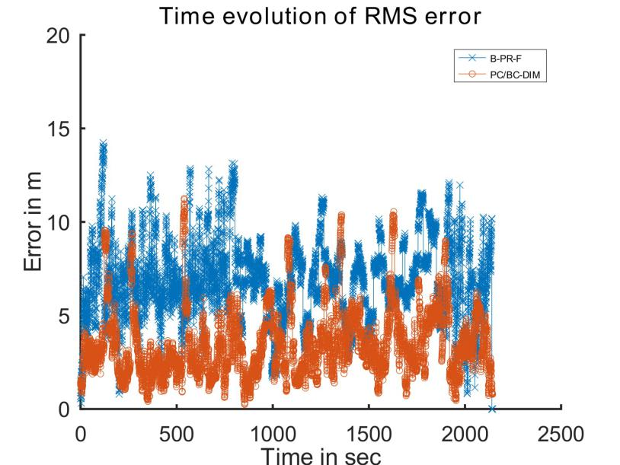

Figure 16 is clearly representing the difference between RMS error of both neural networks. The spikes in PC/BC-DIM can be improved further by increasing the input points of encoding but a minor computation cost will increase. For more deep visualization figure 17 is representing z-axis comparison with GT.

**Figure-4.4: Encoding of Sensory Data**

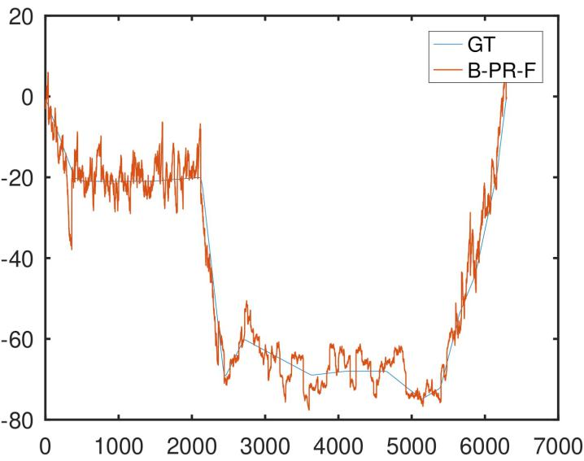

**Figure-4.5: Encoding of Sensory Data**

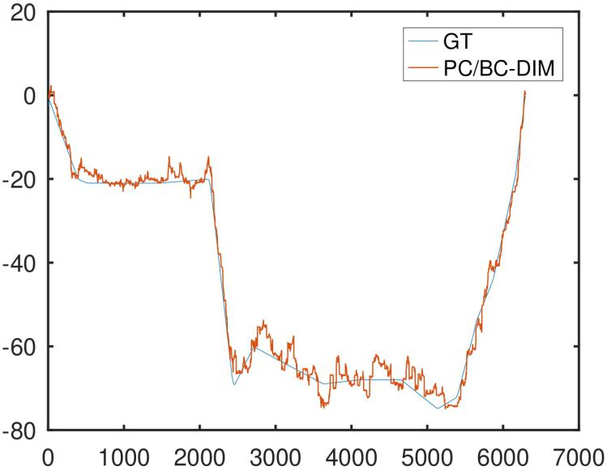

**Figure-4.6: Encoding of Sensory Data**

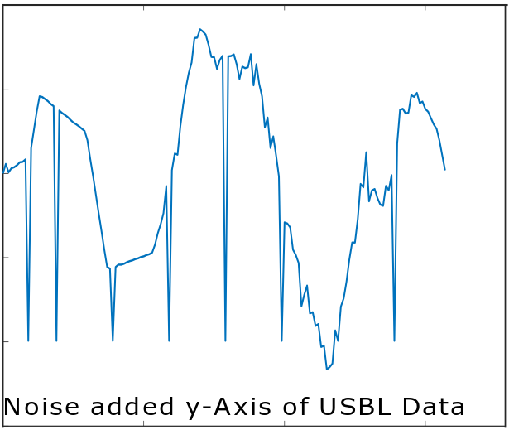

**Figure-4.7: Encoding of Sensory Data**

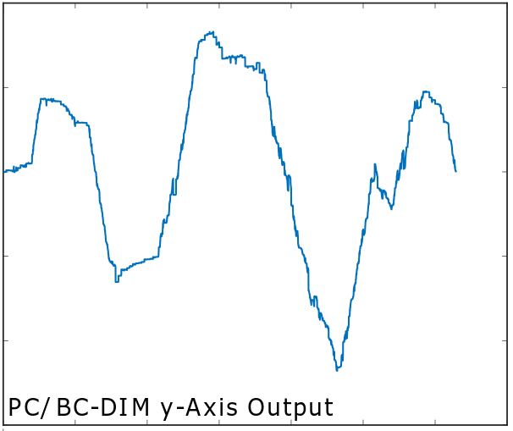

# CHAPTER- 5

## CONCLUSIONS AND DISCISSION

Water covers more than 70 per cent of earth crust which shows there is a green area for searchers to discover and explore underwater resources. It is essential to locate the self-position of the robot to localize something below the surface of the water. GPS and other radio signals do not work below the surface of the water. Acoustic positioning systems are a better choice to locate the vehicle in an unknown underwater environment but low time of arrival and abruption in measuring a position are limitations of acoustic positioning systems. The problem of delay can be reduced by addition of fast data rate sensors such that IMU, DVL, Odometry, SONAR etc. Overcoming the noise of positioning sensors and fusion the absolute positioning information with relative positioning information is main objective of underwater localization. Conventional fusion policies either have low accuracy or high computational cost. Conventional methods are not smart enough to deal with the dynamic nature of water. Modelling of environment and hard mathematical rules make such techniques more complex. In the Kalman filter, we model noise separately but if the environment is dynamic Kalman filter performs poorly because it gives noisy results. Extended Kalman filter can convert the non-linear system to the locally linear but still underwater sensors are highly unpredictable. Particle filter can deal underwater noise by multiple hypotheses but it makes localization process slow even there is less noisy data.

For optimal fusion algorithm, Chame proposed that abrupt noise of USBL can be eliminated by relying on other sensors and reliable data can be considered. For this purpose Chame proposed principle of contextual anticipation which resets in the presence of reliable sensory data of USBL. Sabra proposed that it is better to use different techniques for different environments. Camera-based systems do not have this problem but they can produce a delay in recognition of known landmarks for self-location determining. SONAR are used for find the change in position of robots. This raw information can be converted to useful information to find the current change of vehicle. There is a need to deal with this environment using neural network because they are very modern methods to model non-linearities. PC/BC-DIM neural network is proposed for localizing the vehicle below the surface of the water. Weights are set according to the nature of sensory data and position is estimated. In Experiments, it is observed that more accuracy is achieved as compared to a very recent method using the same sensory data.. In future PC/BC-DIM can be used for underwater image recognition, target tracking and simultaneous localization and mapping.

Our proposed method has a range of equal distance weights so abrupt noise can be overcome because it will be outside the ranges. Other than eliminating noise this filter has ability to make trajectory smooth. Weights can be set differently according to need but here the main focus is to eliminate abrupt noise and fusion of sensory data. Other than Abrupt noise of USBL PC/BC-DIM also reduced dead-reckoning error. We have successfully achieved more accuracy with more efficiency. Other than it as the input comes and reconstruct so by increasing iterations we can achieve more accuracy as the Z-axis of both B-PR-F and PC/BC-DIM is expressed in figure. It is clear to see that PCBC-DIM is fusing the sensory data as well as it is reconstructing individual sensory input to reduce noise.

**REFERENCES**

Akyildiz, I. F., Wang, P., & Sun, Z. (2015). Realizing underwater communication through magnetic induction. IEEE Communications Magazine, 53(11), 42–48.

Allotta, B., Caiti, A., Chisci, L., Costanzi, R., Di Corato, F., Fantacci, C., . . . Ridolfi, A. (2016). An unscented kalman filter based navigation algorithm for autonomous underwater vehicles. Mechatronics, 39, 185–195.

Allotta, B., Caiti, A., Costanzi, R., Fanelli, F., Fenucci, D., Meli, E., & Ridolfi, A. (2015). Unscented kalman filtering for autonomous underwater navigation. In Vi international conference on computational methods in marine engineering marine 2015 (pp. 1–10).

Al-Rawi, M., Galdran, A., Elmgren, F., Rodriguez, J., Bastos, J., & Pinto, M. (2017). Landmark detection from sidescan sonar images. In 2017 ieee jordan conference on applied electrical engineering and computing technologies (aeect) (pp. 1–6).

A´ lvarez-Tun˜o´n, O., Rodr´ıguez, A´ ., Jardo´n, A., & Balaguer, C. (2018). Underwater robot navigation for maintenance and inspection of flooded mine shafts. In 2018 ieee/rsj international conference on intelligent robots and systems (iros) (pp. 1482–1487).

Aras, M., Shahrieel, M., Ab Azis, F., & Othman, M. N. (2012). A low cost 4 dof remotely operated underwater vehicle integrated with imu and pressure sensor. In 4th international conference on underwater system technology: Theory and applications 2012 (usys’12) (pp. 18–23).

Caiti, A., Di Corato, F., Fenucci, D., Allotta, B., Costanzi, R., Monni, N., . . . Ridolfi, A. (2014). Experimental results with a mixed usbl/lbl system for auv navigation. In 2014 underwater communications and networking (ucomms) (pp. 1–4).

Chame, H. F., Dos Santos, M. M., & da Costa Botelho, S. S. (2018). Neural network for black-box fusion of underwater robot localization under unmodeled noise. Robotics and Autonomous Systems, 110, 57–72.

Chen, Z., Zhang, Z., Dai, F., Bu, Y., & Wang, H. (2017). Monocular vision-based underwater object detection. Sensors, 17(8), 1784.

Creuze, V. (2017). Monocular odometry for underwater vehicles with online estimation of the scale factor..

Dellaert, F., & Kaess, M. (2006). Square root sam: Simultaneous localization and mapping via square root information smoothing. The International Journal of Robotics Research, 25(12), 1181–1203.

Dukan, F., & Sørensen, A. J. (2013). Integration filter for aps, dvl, imu and pressure gauge for underwater vehicles.

Fang, S., Wang, Z., & Fan, J. (2019). Integrating sins sensors with odometer measurements for land vehicle navigation system. Journal of Applied Science and Engineering, 22(2), 273287.

Ferrera, M., Moras, J., Trouv´e-Peloux, P., & Creuze, V. (2019). Real-time monocular visual odometry for turbid and dynamic underwater environments. Sensors, 19(3), 687.

Gopalakrishnan, A., Kaisare, N. S., & Narasimhan, S. (2011). Incorporating delayed and infrequent measurements in extended kalman filter based nonlinear state estimation. Journal of Process Control, 21(1), 119–129.

Grøtli, E. I., Tjønn°as, J., Azpiazu, J., Transeth, A. A., & Ludvigsen, M. (2016). Towards more autonomous rov operations: Scalable and modular localization with experiment data. IFAC-PapersOnLine, 49(23), 173–180.

Hegrenæs, Ø., Ramstad, A., Pedersen, T., & Velasco, D. (2016). Validation of a new generation dvl for underwater vehicle navigation. In 2016 ieee/oes autonomous underwater vehicles (auv) (pp. 342–348).

Heidemann, J., Stojanovic, M., & Zorzi, M. (2012). Underwater sensor networks: applications, advances and challenges. Philosophical Transactions of the Royal Society A: Mathematical, Physical and Engineering Sciences, 370(1958), 158–175.

Houegnigan, L., Safari, P., Nadeu, C., van der Schaar, M., Sol´e, M., & Andr´e, M. (2017). High performance supervised time-delay estimation using neural networks. In Ieee international conference on acoustics, speech and signal processing. proceedings.

Huang, Y., & Rao, R. P. (2011). Predictive coding. Wiley Interdisciplinary Reviews: Cognitive Science, 2(5), 580–593.

Huang, Y., Zhang, Y., Xu, B., Wu, Z., & Chambers, J. A. (2017). A new adaptive extended kalman filter for cooperative localization. IEEE Transactions on Aerospace and Electronic Systems, 54(1), 353–368.

Johannsson, H., Kaess, M., Englot, B., Hover, F., & Leonard, J. (2010). Imaging sonar-aided navigation for autonomous underwater harbor surveillance. In 2010 ieee/rsj international conference on intelligent robots and systems (pp. 4396–4403).

Karimi, M., Bozorg, M., & Khayatian, A. (2013). A comparison of dvl/ins fusion by ukf and ekf to localize an autonomous underwater vehicle. In 2013 first rsi/ism international conference on robotics and mechatronics (icrom) (pp. 62–67).

Karras, G. C., & Kyriakopoulos, K. J. (2007). Localization of an underwater vehicle using an imu and a laser-based vision system. In 2007 mediterranean conference on control & automation (pp. 1–6).

Ko, N. Y., Kim, T. G., & Noh, S. W. (2011). Monte carlo localization of underwater robot using internal and external information. In 2011 ieee asia-pacific services computing conference (pp. 410–415).

Ko, N. Y., Noh, S. W., & Choi, H. T. (2014). Simultaneous estimation of sea level and underwater vehicle location. In Oceans 2014-taipei (pp. 1–5).

Lawrence, M. W. (1985). Ray theory modeling applied to low-frequency acoustic interaction with horizontally stratified ocean bottoms. The Journal of the Acoustical Society of America, 78(2), 649–658.

Lebastard, V., Chevallereau, C., Amrouche, A., Jawad, B., Girin, A., Boyer, F., & Gossiaux, P. B. (2010). Underwater robot navigation around a sphere using electrolocation sense and kalman filter. In 2010 ieee/rsj international conference on intelligent robots and systems (pp. 4225–4230).

Lee, C.-m., Hong, S.-W., & Seong, W.-J. (2003). An integrated dvl/imu system for precise navigation of an autonomous underwater vehicle. In Oceans 2003. celebrating the past... teaming toward the future (ieee cat. no. 03ch37492) (Vol. 5, pp. 2397–Vol).

Leonard, J. J., & Bahr, A. (2016). Autonomous underwater vehicle navigation. In Springer handbook of ocean engineering (pp. 341–358). Springer.

Li, H., He, Y., Cheng, X., Zhu, H., & Sun, L. (2015). Security and privacy in localization for underwater sensor networks. IEEE Communications Magazine, 53(11), 56–62.

Li, W., Wang, J., Lu, L., & Wu, W. (2013). A novel scheme for dvl-aided sins in-motion alignment using ukf techniques. Sensors, 13(1), 1046–1063.

MahmoudZadeh, S., Powers, D. M., & Zadeh, R. B. (2019). Introduction to autonomy and applications. In Autonomy and unmanned vehicles (pp. 1–15). Springer.

Mandi´c, F., Renduli´c, I., Miˇskovi´c, N., & Na, . (2016). Underwater object tracking using sonar and usbl measurements. Journal of Sensors, 2016.

Medagoda, L., Williams, S. B., Pizarro, O., & Jakuba, M. V. (2011). Water column current profile aided localisation combined with view-based slam for autonomous underwater vehicle navigation. In 2011 ieee international conference on robotics and automation (pp. 3048–3055).

Miller, A., Miller, B., & Miller, G. (2018). Auv navigation with seabed acoustic sensing. In 2018 australian & new zealand control conference (anzcc) (pp. 166–171).

Muhammad, N., Toming, G., Tuhtan, J. A., Musall, M., & Kruusmaa, M. (2017). Underwater map-based localization using flow features. Autonomous Robots, 41(2), 417–436.

Pan, X., & Wu, Y. (2016). Underwater doppler navigation with self-calibration. The Journal of Navigation, 69(2), 295–312.

Paull, L., Saeedi, S., Seto, M., & Li, H. (2013). Auv navigation and localization: A review. IEEE Journal of Oceanic Engineering, 39(1), 131–149.

Petillot, Y., Maurelli, F., Valeyrie, N., Mallios, A., Ridao, P., Aulinas, J., & Salvi, J. (2010). Acoustic-based techniques for autonomous underwater vehicle localization. Proceedings of the Institution of Mechanical Engineers, Part M: Journal of Engineering for the Maritime Environment, 224(4), 293–307.

Petrich, J., Brown, M. F., Pentzer, J. L., & Sustersic, J. P. (2018). Side scan sonar based self-localization for small autonomous underwater vehicles. Ocean Engineering, 161, 221–226.

Ranjan, T., Nherakkol, A., & Navelkar, G. (2010). Navigation of autonomous underwater vehicle using extended kalman filter. In Fira roboworld congress (pp. 1–9).

Rhudy, M. B., Gu, Y., & Napolitano, M. (2013). Does the unscented kalman filter converge faster than the extended kalman filter? a counter example. In Aiaa guidance, navigation, and control (gnc) conference (p. 5198).

Ribas, D., Ridao, P., Cuf´ı, X., & El-fakdi, A. (2003). Towards a dvl-based navigation system for an underwater robot. In 4th workshop on european scientific and industrial collaboration.

Ribas, D., Ridao, P., Neira, J., & Tardos, J. D. (2006). Slam using an imaging sonar for partially structured underwater environments. In 2006 ieee/rsj international conference on intelligent robots and systems (pp. 5040–5045).

Rigby, P., Pizarro, O., &Williams, S. B. (2006). Towards geo-referenced auv navigation through fusion of usbl and dvl measurements. In Oceans 2006 (pp. 1–6).

Sabet, M. T., Sarhadi, P., & Zarini, M. (2014). Extended and unscented kalman filters for parameter estimation of an autonomous underwater vehicle. Ocean Engineering, 91, (Page 29 of 30 ) 329–339.

Sabra, A., & Fung, W.-k. (2017). Dynamic localization plan for underwater mobile sensor nodes using fuzzy decision support system. In Oceans 2017-anchorage (pp. 1–8).

Shao, X., He, B., Guo, J., & Yan, T. (2016). The application of auv navigation based on adaptive extended kalman filter. In Oceans 2016-shanghai (pp. 1–4).

Silveira, L., Guth, F., Drews-Jr, P., Ballester, P., Machado, M., Codevilla, F., . . . Botelho, S. (2015). An open-source bio-inspired solution to underwater slam. IFAC-PapersOnLine, 48(2), 212–217.

Spratling, M.W. (2008). Predictive coding as a model of biased competition in visual attention. Vision research, 48(12), 1391–1408.

Spratling, M. W., De Meyer, K., & Kompass, R. (2009). Unsupervised learning of overlapping image components using divisive input modulation. Computational intelligence and neuroscience, 2009.

Tal, A., Klein, I., & Katz, R. (2017). Inertial navigation system/doppler velocity log (ins/dvl) fusion with partial dvl measurements. Sensors, 17(2), 415.

Tan, H.-P., Diamant, R., Seah, W. K., & Waldmeyer, M. (2011). A survey of techniques and challenges in underwater localization. Ocean Engineering, 38(14-15), 1663–1676.

Vallicrosa, G., & Ridao, P. (2018). H-slam: Rao-blackwellized particle filter slam using hilbert maps. Sensors, 18(5), 1386.

Vasilijevic, A., Borovic, B., & Vukic, Z. (2012). Underwater vehicle localization with complementary filter: performance analysis in the shallow water environment. Journal of intelligent & robotic systems, 68(3-4), 373–386.

Wan, E. A., & Van Der Merwe, R. (2000). The unscented kalman filter for nonlinear estimation. In Proceedings of the ieee 2000 adaptive systems for signal processing, communications, and control symposium (cat. no. 00ex373) (pp. 153–158).

Zhang, J., Wang, W., Xie, G., & Shi, H. (2014). Camera-imu-based underwater localization. In Proceedings of the 33rd chinese control conference (pp. 8589–8594).

Zhang, T., Chen, L., & Li, Y. (2016). Auv underwater positioning algorithm based on interactive assistance of sins and lbl. Sensors, 16(1), 42.

**APPENDIX-01**

|  |  |  |  |  |
| --- | --- | --- | --- | --- |
| **Abbreviations Used in the Thesis** | | | | |
| **S #** | **Items** | | | **Abbreviations** |
| **1** | Transmission and Distribution | | | T&D |
| **2** | Gujranwala Electric Power Company | | | GEPCO |
| **3** | Karachi Electric Supply Company | | | KESC |
| **4** | Water and Power Development Authority | | | WAPDA |
| **5** | Pakistan Atomic Energy Commission | | | PAEC |
| **6** | Karachi Nuclear Power Plant | | | KANUPP |
| **7** | Independent Power Producers | | | IPPs |
| **8** | Captive Power Producers | | | CPPs |
| **9** | Small Power Producers | | | SPPs |
| **10** | Gross Domestic Product | | | GDP |
| **11** | National Transmission and Dispatch Company | | | NTDC |
| **12** | Alternative Energy Development Board | | | AEDB |
| **13** | Pakistan Electric Power Company | | | PEPCO |
| **14** | Private Power Infrastructure Board | | | PPIB |
| **15** | Generation Companies | | | GENCOs |
| **16** | Distribution Companies | | | DISCOs |
| **17** | National Electric Power regularity Authority | | | NEPRA |
| **18** | Chashma Nuclear Power Plant Unit | | | CHASNUPP |
| **19** | Government of Pakistan | | | GoP |
| **20** | Supervisory Control and Data Acquisition | | | SCADA |
| **21** | Non-Technical Losses | | | NTLs |
| **22** | No Load | | | NL |
| **23** | Advanced Metering Infrastructure | | | AMI |
| **24** | Distributed Generation | | | DG |
| **25** | Volt VAr Optimization | | | VVO |
| **26** | Electrical Transient Analyzer Program | | | ETAP |
| **27** | Mian Muhammad Panah | | | MMP |
| **28** | Small Industrial Estate | | | SIE |
|  | |  |  | |

**APPENDIX-02**

|  |  |  |  |  |
| --- | --- | --- | --- | --- |
| ***Turnitin* Originality Report** | | | | |
| Tested on July 24, 2019, by Turnitin Anti Plagiarism Software Provided by Higher Education Commission, Pakistan to the Instructors of the University of Gujrat, Punjab, Pakistan. | | | | |
| Thesis Title: Improving Indigenous Distribution Power System Efficiency Using Power Loss Reduction  Authors’ Name:Muhammad Ramiz  Institution: University Of Gujrat Hafiz Hayat Campus | | | | |
| **PRIMARY SOURCES** | | | | |
| **SIMILARITY INDEX** | **INTERNET SOURCES** | **PUBLICATIONS** | **STUDENT PAPERS** | |
| **13%** | **04%** | **04%** | **10%** | |
| **Internet Source** | | | | **04%** |
| 1. wiredspace.wits.ac.za(Internet Source) | | | |
| 1. pe.org.pl(Internet Source) | | | |
| 1. daimoninterplan.com.br(Internet Source) | | | |
| 1. cppg.fccollege.edu.pk(Internet Source) | | | |
| 1. www.provedor.nuca.ie.ufrj.br(Internet Source) | | | |
| 1. repository.up.ac.za(Internet Source) | | | |
| 1. scholar.sun.ac.za(Internet Source) | | | |
| 1. hdl.handle.net(Internet Source) | | | |
| 1. wano.org.uk(Internet Source) | | | |
| 1. scholarbank.nus.edu.sg(Internet Source) | | | |
| 1. www.mdpi.com(Internet Source) | | | |
| 1. www.nepra.org.pk(Internet Source) | | | |
| 1. repository.cardiffmet.ac.uk(Internet Source) | | | |
| 1. repository.lib.polyu.edu.hk(Internet Source) | | | |
| 1. aircconline.com(Internet Source) | | | |
| 1. www.iiste.org(Internet Source) | | | |
| 1. www.dawn.com(Internet Source) | | | |
| **Publications** | | | | **04%** |
| 1. H.W. Ng, R. Hasegawa, A.C. Lee, L.A. Lowdermilk. "Amorphous alloy core distribution transformers", Proceedings of the IEEE, 1991 (Publication) | | | |
| 1. M. Stojkov, K. Trupinic, S. Nikolovski. "Technical losses in power distribution network", MELECON 2006 - 2006 IEEE Mediterranean Electrotechnical Conference, 2006 (Publication) | | | |
| 1. Julio Romero Aguero. "Improving the efficiency of power distribution systems through technical and non-technical losses reduction", PES T&D 2012, 2012 (Publication) | | | |
| 1. Muhammad Kamran. "Current status and future success of renewable energy in Pakistan", Renewable and Sustainable Energy Reviews, 2018 (Publication) | | | |
| 1. Rauf, Omer, Shujie Wang, Peng Yuan, and Junzhe Tan. "An overview of energy status and development in Pakistan", Renewable and Sustainable Energy Reviews, 2015 (Publication) | | | |
| 1. Steinmetz, Thorsten, Bogdan Cranganu-Cretu, and Jasmin Smajic. "Investigations of no-load and load losses in amorphous core dry-type transformers", The XIX International Conference on Electrical Machines - ICEM 2010, 2010 (Publication) | | | |
| 1. "Evaluation of the Optimal Connection of Power Transformers in the Substations of a Hospital", Energies, 2018 (Publication) | | | |
| 1. "Advanced Technologies, Systems, and Applications II", Springer Nature, 2018 (Publication) | | | |
| 1. Perumalraja Rengaraju, Shunmugham R. Pandian, Chung-Horng Lung. "Communication networks and non-technical energy loss control system for smart grid networks", 2014 IEEE Innovative Smart Grid Technologies – Asia (ISGT ASIA), 2014 (Publication) | | | |
| 1. Muhammad Kamran, Muhammad Rayyan Fazal, Muhammad Mudassar. "Towards empowerment of the renewable energy sector in Pakistan for sustainable energy evolution: SWOT analysis", Renewable Energy, 2020 (Publication) | | | |
| 1. Juan C. Olivares-Galvan, Pavlos S. Georgilakis, Eduardo Campero-Littlewood, Rafael Escarela- Perez. "Core lamination selection for distribution transformers based on sensitivity analysis", Electrical Engineering, 2012(Publication) | | | |
| 1. Steven Hodder, Bogdan Kasztenny, Normann Fischer, Yu Xia. "Low second-harmonic content in transformer inrush currents - Analysis and practical solutions for protection security", 2014 67th Annual Conference for Protective Relay Engineers, 2014 (Publication) | | | |
| 1. "Proceedings of International Conference on ICT for Sustainable Development", Springer Science and Business Media LLC, 2016 (Publication) | | | |
| 1. "9th International Conference on Robotic, Vision, Signal Processing and Power Applications", Springer Science and Business Media LLC, 2017 (Publication) | | | |
| 1. "Renewable Energy and the Environment", Springer Nature, 2018(Publication) | | | |
| 1. Sushrut Thakar, Vijay A.S., Suryanarayana Doolla. "System reconfiguration in microgrids", Sustainable Energy, Grids and Networks, 2019(Publication) | | | |
| 1. Amine Allouhi, Ali Boharb, Rahman Saidur, Tarik Kousksou, Abdelmajid Jamil. "5.1 Energy Auditing", Elsevier BV, 2018 (Publication) | | | |
| 1. "Energy, Environment and Sustainable Development", Springer Nature, 2012(Publication) | | | |
| 1. Mazhar Baloch, Safdar Abro, Ghulam Sarwar Kaloi, Nayyar Mirjat, Sohaib Tahir, M. Nadeem, Mehr Gul, Zubair Memon, Mahendar Kumar. "A Research on Electricity Generation from Wind Corridors of Pakistan (Two Provinces): A Technical Proposal for Remote Zones",Sustainability, 2017(Publication) | | | |
| 1. Wajahat Ullah Khan Tareen, Zuha Anjum, Nabila Yasin, Leenah Siddiqui et al. "The Prospective Non-Conventional Alternate and Renewable Energy Sources in Pakistan—A Focus on Biomass Energy for Power Generation, Transportation, and Industrial Fuel",Energies, 2018 (Publication) | | | |
| 1. Tanveer Ahmad, Qadeer Ul Hasan. "Detection of Frauds and Other Non-technical Losses in Power Utilities using Smart Meters: A Review", International Journal of Emerging Electric Power Systems, 2016(Publication) | | | |
| 1. Muhammad Sufyan Javed, Rizwan Raza, Irtaza Hassan, Rehan Saeed, Nusrat, Javed Iqbal. "The energy crisis in Pakistan: A possible solution via biomass-based waste", Journal of Renewable and Sustainable Energy, 2016 (Publication) | | | |
| **Student Paper** | | | | **07%** |
| 1. Submitted to Higher Education Commission Pakistan (Student Paper) | | | |
| 1. Submitted to University of Sydney(Student Paper) | | | |
| 1. Submitted to University of Birmingham(Student Paper) | | | |
| 1. Submitted to Nazarbayev University(Student Paper) | | | |
| 1. Submitted to North West University(Student Paper) | | | |
| 1. Submitted to University of Strathclyde(Student Paper) | | | |
| 1. Submitted to Ghana Technology University College(Student Paper) | | | |
| 1. Submitted to Universiti Putra Malaysia(Student Paper) | | | |
| 1. Submitted to Asian Institute of Technology(Student Paper) | | | |
| 1. Submitted to Colorado Technical University Online(Student Paper) | | | |
| 1. Submitted to University of Warwick(Student Paper) | | | |
| 1. Submitted to University of Surrey(Student Paper) | | | |
| 1. Submitted to University of Technology, Sydney(Student Paper) | | | |
| 1. Submitted to Imperial College of Science and Medicine(Student Paper) | | | |
| 1. Submitted to Furness College(Student Paper) | | | |
| 1. Submitted to The University of Manchester(Student Paper) | | | |
| 1. Submitted to De Montfort University(Student Paper) | | | |
| 1. Submitted to University of Portsmouth(Student Paper) | | | |
| 1. Submitted to Cranfield University(Student Paper) | | | |
| 1. Submitted to University of Bath(Student Paper) | | | |
| 1. Submitted to Panjab University(Student Paper) | | | |
| 1. Submitted to University of Aberdeen(Student Paper) | | | |
| 1. Submitted to Engineers Australia (Student Paper) | | | |
| 1. Submitted to 1611(Student Paper) | | | |
| 1. Submitted to Queen Mary and Westfield College(Student Paper) | | | |
| 1. Submitted to Federal University of Technology(Student Paper) | | | |
| 1. Submitted to National University of Singapore(Student Paper) | | | |
| 1. Submitted to Heriot-Watt University(Student Paper) | | | |
| 1. Submitted to Engineering Institute of Technology (Student Paper) | | | |
| 1. Submitted to The Robert Gordon University(Student Paper) | | | |
| 1. Submitted to Trafford College(Student Paper) | | | |
| 1. Submitted to University of Newcastle upon Tyne (Student Paper) | | | |
| 1. Submitted to University of Pretoria(Student Paper) | | | |
| 1. Submitted to Oklahoma State University(Student Paper) | | | |
| 1. Submitted to Deakin University(Student Paper) | | | |
| 1. Submitted to School of Business and Management ITB (Student Paper) | | | |
| 1. Submitted to Glasgow Caledonian University(Student Paper) | | | |
| 1. Submitted to Loughborough University(Student Paper) | | | |
| 1. Submitted to Guru Nanak Dev Engineering College (Student Paper) | | | |
| 1. Submitted to CSU, San Jose State University(Student Paper) | | | |
| 1. Submitted to VIT University(Student Paper) | | | |
| 1. Submitted to Solihull College, West Midlands(Student Paper) | | | |
| 1. Submitted to Fakultas Ekonomi Universitas Indonesia (Student Paper) | | | |
| 1. Submitted to Institute of Technology, Tallaght(Student Paper) | | | |
| 1. Submitted to Mancosa(Student Paper) | | | |
| 1. Submitted to Brisbane State High School(Student Paper) | | | |
| 1. Submitted to University of Huddersfield(Student Paper) | | | |